A
MAJOR PROJECT
ON

Protein Family Classification using Deep Learning Techniques
Submitted in partial fulfillment for the award of the degree of

BACHELOR OF TECHNOLOGY

IN

COMPUTER SCIENCE & ENGINEERING (DATA SCIENCE)
By
PINNINTI MAHIDAR REDDY 22Q91A67G8
RANGARAJ DEEPIKA 22Q91A67H3
SHAIK SAIFUDDIN 22Q91A67I0

Under the guidance of

Mrs. Bhagya Lakshmi
Assistant Professor, Dept. of CSE-DS

DEPARTMENT OF COMPUTER SCIENCE & ENGINEERING

(DATA SCIENCE)

MALLA REDDY COLLEGE OF ENGINEERING
(Approved by AICTE-Permanently Affiliated to JNTU-Hyderabad)
Accredited by NBA, Recognized section 2(f) & 12(B) of UGC New Delhi
ISO 9001:2015 certified Institution
Maisammaguda, Dhulapally (Post via Kompally), Secunderabad- 500100
2025 – 2026
MALLAREDDYCOLLEGEOFENGINEERING
(Approved by AICTE-Permanently Affiliated to JNTU-Hyderabad)
Accredited by NBA, Recognized section 2(f) & 12(B) of UGC New Delhi ISO
9001:2015 certified Institution
Maisammaguda, Dhulapally (Post via Kompally), Secunderabad- 500100

DEPARTMENT OF COMPUTER SCIENCE & ENGINEERING (DATA SCIENCE)

CERTIFICATE
This is to certify that the Major Project on “Protein Family Classification using Deep Learning Techniques” is successfully done by following students of Department of Computer Science & Engineering (Data Science) of our college in partial fulfillment of the requirement for the award of Bachelor of Technology Degree in the year 2025-2026.The result embodied in this report have not been submitted to any other University for the award of any Diploma or Degree.
PINNINTI MAHIDAR REDDY 22Q91A67G8
RANGARAJ DEEPIKA 22Q91A67H3
SHAIK SAIFUDDIN 22Q91A67I0

Submitted for the viva voice examination held on: ______________________________
INTERNAL GUIDE | PROJECT COORDINATOR | HOD

Mrs. Bhagya Lakshmi Dr. Madaraboina Naresh Dr. J. Britto
Associate Professor Assistant Professor Professor & Head

Internal Examiner External Examiner

DECLARATION
We, PINNINTI MAHIDAR REDDY, RANGARAJ DEEPIKA, SHAIK SAIFUDDIN with Regd.no. 22Q91A67G8, 22Q91A67H3, 22Q91A67I0 are hereby declaring that the major project entitled “Protein Family Classification using Deep Learning Techniques” has done by us under the guidance of Mrs. Bhagya Lakshmi Assistant Professor, Department of Computer Science and Engineering (Data science) is submitted in the partial fulfilment of the requirements for the award of degree of BACHELOR OF TECHNOLOGY in COMPUTER SCIENCE and ENGINEERING (DATA SCIENCE).
The Result embedded in this project report have not been submitted to any other University or institute for the award of any degree or diploma.

Signature of the Candidate

PINNINTI MAHIDAR REDDY | : 22Q91A67G8
RANGARAJ DEEPIKA | : 22Q91A67H3
SHAIK SAIFUDDIN | : 22Q91A67I0

DATE:
PLACE: Maisammaguda

ACKNOWLEDGEMENT
First and foremost, we would like to express our immense gratitude towards our institution Malla Reddy College of Engineering, which helped us to attain profound technical skills in the field of Computer Science & Engineering, there by fulfilling our most cherished goal.
We are pleased to thank Sri Ch. Malla Reddy, our Founder Chairman MRGI, Sri Ch. Mahender Reddy, Secretary, MRGI for providing this opportunity and support throughout the course.
It gives us immense pleasure to acknowledge the perennial inspiration of Dr.M. Ashok our beloved principal for his kind co-operation and encouragement in bringing out this task.
We would like to thank Dr.J.G.M. Britto Professor & HOD, CSE(DS) Department for their inspiration adroit guidance and constructive criticism for successful completion of our degree.
We would like to thank Dr. Madaraboina Naresh Assistant professor, our project coordinator, for his valuable suggestions and guidance during the exhibition and completion of this project.
We would like to thank Mrs. Bhagya Lakshmi Assistant professor, our project guide, for his valuable suggestions and guidance during the exhibition and completion of this project.
Finally, we avail this opportunity to express our deep gratitude to all staff who have contribute their valuable assistance and support making our project success.
PINNINTI MAHIDAR REDDY |  | 22Q91A67G8
RANGARAJ DEEPIKA |  | 22Q91A67H3
SHAIK SAIFUDDIN |  | 22Q91A67I0

Protein Family Classification using Deep Learning Techniques

TABLE CONTENTS
CHAPTER NO | TITLE | PAGE NO
A | LIST OF FIGURES | I
B | LIST OF SCREENS | II
C | LIST OF ACRONYMS AND ABBREVATIONS | III
D | ABSTRACT | IV
1 | CHAPTER 1: INTRODUCTION  1.1 INTRODUCTION  1.2 OBJECTIVE  1.3 BACKGROUND OF THE STUDY  1.4 PROBLEM STATEMENT  1.5 SCOPE OF THE STUDY  1.6 SIGNIFICANCE OF THE STUDY | 1  1-4  5-6  7  8  9-11  11-12
2 | CHAPTER 2: LITERATURE SURVEY | 13-17
3 | CHAPTER 3: SYSTEM ANALYSIS  3.1 EXISTING SYSTEM  3.2 PROPOSED SYSTEM | 18-20  19  20-21
4 | CHAPTER 4: SYSTEM REQUIREMENTS  4.1 HARDWARE REQUIREMENTS  4.2 SOFTWARE REQUIREMENTS  4.2.1 PYTHON LIBRARIES  4.3 FEASIBILITY STUDY | 22-23  23  23  23  24-25
5 | CHAPTER 5: DETAILED DESIGN  5.1 SYSTEM ARCHITECTURE  5.2 UML DIAGRAMS  5.2.1 CLASS DIAGRAM  5.2.2 USECASE DIAGRAM  5.2.3 SEQUENCE DIAGRAM  5.2.4 ACTIVITY DIAGRAM  5.2.5 DATA FLOW DIAGRAM  5.2.6 COLLABORATION DIAGRAM  5.2.7 COMPONENT DIAGRAM  5.2.8 DEPLOYMENT DIAGRAM | 26-36  27  28-29  30  31  32  33  34  35  36  37
6 | CHAPTER 6: IMPLEMENTATION  6.1 ADMIN MODULE  6.2 USER MODULE  6.3 TECHNOLOGIES AND ALGORITHMS USED  6.4 SOURCE CODE | 38-56  40  41  42-44  45-59
7 | CHAPTER 7: TESTING  7.1. PURPOSE OF TESTING  7.2. TYPES OF TESTING PERFORMED  7.2.1 UNIT TESTING  7.2.2 INTEGRATION TESTING  7.2.3 SYSTEM TESTING  7.2.4 MODEL VALIDATION TESTING  7.3. PERFORMANCE TESTING  7.4. TESTING RESULTS (SAMPLE FORMAT)  7.5. ERROR ANALYSIS  7.6. CONCLUSION OF TESTING | 60-64  61  61  61  62  62  62  63  63  64  64
8 | CHAPTER 8: RESULT | 65-74
9 | CHAPTER 9: CONCLUSION | 75-76
10 | CHAPTER 10: FUTURE ENHANCEMENTS | 77-79
11 | CHAPTER 11: REFERENCES | 80-81

LIST OF ACRONYMS AND ABBREVATIONS

S.no | ACROYNM | DESCRIPTION
1 | RNN | Recurrent Neural Network
2 | LSTM | Long Short-Term Memory
3 | GRU | Gated Recurrent Unit
4 | SVM | Support Vector Machine
5 | K-NN | K-Nearest Neighbors
6 | CASP | Critical Assessment of Structure Prediction
7 | GPU | Graphics Processing Unit

LIST OF FIGURES
FIGURE NO | NAME OF THE FIGURE | PAGE NO.
5.1 | System Architecture | 25
5.2. | Uml Diagram | 27
5.2.1 | Class Diagram | 28
5.2.2 | Use Case Diagram | 29
5.2.3 | Sequence Diagram | 30
5.2.4 | Activity Diagram | 31
5.2.5 | Data Flow Diagram | 32
5.2.6 | Collaboration Diagram | 33
5.2.7 | Deployment Diagram | 34

LIST OF SCREENSHOTS
Figure No | Name of Screenshot | Page No
8.1 | Python Server Started | 65
8.2 | New User Register | 65
8.3 | Entering Sign Up Details | 66
8.4 | User Login Done | 66
8.5 | Login | 67
8.6 | Load & Processed Dataset | 67
8.7 | In Above Screen Dataset Loaded | 68
8.8 | Training Records | 69
8.9 | Selecting And Uploading  ‘testSequences.npy’ File | 70
8.10 | Test Data Values | 71

ABSTRACT
Protein family classification is a vital aspect of bioinformatics research, as it helps scientists understand the structural and functional relationships among proteins. Proteins sharing similar sequences often exhibit similar biological roles, and identifying these relationships allows researchers to predict functions of unknown proteins, study evolutionary pathways, and design targeted drugs. In this project, we focus on developing a deep learning-based system for protein family prediction using advanced neural network architectures such as Gated Recurrent Unit (GRU), Recurrent Neural Network (RNN), and Long Short-Term Memory (LSTM). These models are highly effective in handling sequential data like protein sequences, as they can capture long-range dependencies and sequence patterns that are crucial for accurate classification.The dataset employed in this project is derived from the CASP protein sequences available in SideChainNet, a comprehensive database that provides detailed structural and biochemical information, including atomic coordinates, torsion angles, and amino acid sequences. Given the large size and complexity of the dataset, feature extraction and preprocessing are performed using Google Colab’s GPU to leverage its computational efficiency. The extracted and preprocessed features are stored in NumPy (.npy) format, which allows for fast loading and reuse during subsequent experiments, minimizing computational overhead. The system architecture is designed to be modular and user-friendly, comprising several integrated components such as user registration, login, dataset management, model training, and family classification. Through an intuitive interface, users can easily upload datasets, preprocess them, split the data into training and testing subsets, and select from multiple deep learning models for training. Once the models are trained, users can input new or test sequences to predict their respective protein families. Model performance is thoroughly evaluated using standard machine learning metrics such as accuracy, precision, recall, and F-score, which provide insights into the strengths and weaknesses of each model. To offer visual insights, the results are presented in the form of graphs and confusion matrices, helping users compare and interpret model behavior effectively. This deep learning-based system provides an efficient and automated approach to protein family classification, enabling researchers to explore complex biological data, accelerate protein function prediction, and contribute to advancements in computational biology and biomedical research.

CHAPTER 1: INTRODUCTION

INTRODUCTION
Proteins are the fundamental building blocks of life, performing a wide array of biological functions within cells—ranging from catalyzing metabolic reactions and DNA replication to structural support and cellular signaling. Each protein’s function is primarily determined by its sequence of amino acids, which folds into a specific three-dimensional structure. Understanding and classifying proteins into their respective families is therefore a critical task in bioinformatics and computational biology, as it provides insight into their function, evolutionary relationships, and potential role in disease mechanisms. However, with the exponential growth of biological data generated by high-throughput sequencing technologies, traditional methods for protein classification—such as sequence alignment and motif-based techniques—have become increasingly insufficient. To address these challenges, Deep Learning (DL) has emerged as a powerful tool capable of automatically extracting high-level features from raw sequence data, leading to significant advances in Protein Family Classification.

The Protein Family Classification using Deep Learning Techniques project leverages advanced neural network architectures to identify and categorize proteins based on their amino acid sequences, physicochemical properties, and evolutionary information. Protein families consist of groups of related proteins that share similar structural domains or sequence motifs, often implying similar biological functions. Traditionally, classification has relied on manual curation or heuristic-based algorithms such as BLAST (Basic Local Alignment Search Tool), HMMER, and multiple sequence alignment (MSA) techniques. While effective for small datasets, these approaches struggle to scale efficiently and accurately with the vast number of new protein sequences being discovered daily in public databases such as UniProt, Pfam, and PDB. Deep Learning offers a data-driven solution by learning complex hierarchical representations directly from protein sequences—eliminating the need for hand-crafted feature engineering and improving both speed and accuracy.

Deep Learning architectures such as Convolutional Neural Networks (CNNs), Recurrent Neural Networks (RNNs), and Transformer-based models have demonstrated exceptional performance in modeling biological sequences. CNNs are particularly effective in detecting local sequence motifs or conserved regions, similar to how they detect spatial features in images. In contrast, RNNs—especially Long Short-Term Memory (LSTM) and Gated Recurrent Unit (GRU) models—are adept at capturing sequential dependencies and long-range relationships in amino acid chains. More recently, Transformer architectures, exemplified by models like BERT and AlphaFold’s Evoformer block, have revolutionized biological sequence analysis by employing attention mechanisms that capture contextual relationships between residues without the limitations of sequential processing. By combining these deep learning approaches, the proposed model achieves high precision in classifying protein families, even in cases where traditional alignment-based methods fail due to low sequence similarity.

The process begins with data collection and preprocessing, where protein sequences are extracted from curated databases such as Pfam, UniProtKB, or InterPro. Each sequence undergoes encoding, where amino acids are converted into numerical vectors through techniques such as one-hot encoding, k-mer representation, or more advanced embeddings like ProtVec and BioBERT. These embeddings capture both biochemical and contextual properties of amino acids, serving as the input features for the deep learning model. Feature normalization and augmentation strategies are applied to ensure that the dataset remains balanced and generalizable across different protein families.

The proposed Deep Learning model is then trained to identify complex sequence patterns and predict the family to which a given protein belongs. During training, the network optimizes weights using loss functions such as categorical cross-entropy and employs optimizers like Adam or RMSProp to enhance convergence. Regularization techniques such as dropout and batch normalization are used to prevent overfitting and improve model generalization. After training, the model is evaluated on unseen test data to measure classification accuracy, precision, recall, and F1-score. In many studies, deep learning models have achieved accuracy rates exceeding 95%, outperforming conventional machine learning and sequence alignment techniques.

One of the most compelling advantages of deep learning in protein classification lies in its ability to learn from raw, unaligned data. This eliminates the computationally expensive step of sequence alignment and allows the model to generalize across distantly related protein families that share structural or functional similarities but exhibit low sequence identity. Additionally, the integration of evolutionary information, such as Position-Specific Scoring Matrices (PSSMs) and Hidden Markov Model (HMM) profiles, further enhances the discriminative power of deep learning models by providing context from multiple sequence alignments without explicit manual alignment.

Beyond classification, the insights derived from deep learning models have far-reaching implications in drug discovery, genomics, and molecular medicine. By accurately identifying protein families, researchers can infer the function of newly discovered proteins, predict potential drug targets, and study the evolution of protein domains. For instance, identifying a novel protein as belonging to a family associated with a specific enzymatic function can guide laboratory validation and subsequent therapeutic exploration. Moreover, explainable AI techniques are now being incorporated to interpret which sequence features or motifs contribute most significantly to classification, enhancing the model’s transparency and biological interpretability.

The scalability of deep learning frameworks makes them highly suitable for deployment in automated bioinformatics pipelines. Cloud-based systems and GPU-accelerated platforms enable large-scale training and real-time classification of millions of protein sequences. In the context of personalized medicine, such systems can help identify disease-related mutations or classify proteins derived from patient-specific genomes, paving the way for precision diagnostics and targeted therapeutics.

In conclusion, Protein Family Classification using Deep Learning Techniques represents a major advancement in computational biology, bridging the gap between raw biological data and functional understanding. By leveraging CNNs, RNNs, and Transformers, the system can autonomously learn complex sequence representations and achieve superior accuracy over traditional approaches. This innovation not only accelerates the annotation of newly sequenced proteins but also contributes to deeper insights into molecular biology, evolution, and disease mechanisms. As the intersection of AI and bioinformatics continues to evolve, deep learning-driven protein classification will play an increasingly pivotal role in biological research, enabling faster discoveries and more effective biomedical applications in the era of data-intensive life sciences.

1.2 OBJECTIVE
The main objective of this project is to design and develop an intelligent system that can accurately classify proteins into their respective families using advanced deep learning techniques. Protein family classification is an important task in bioinformatics because proteins with similar sequences often share similar biological functions and structural properties. By applying modern artificial intelligence methods, this project aims to improve the efficiency, scalability, and accuracy of protein classification.
- To develop an automated protein family classification system
In The primary objective of this project is to build an automated system capable of identifying and classifying proteins into their respective families based on amino acid sequences. The system reduces the need for manual analysis and provides faster and more reliable classification results.
- To utilize deep learning techniques for biological sequence analysis
The project aims to implement advanced deep learning models such as Recurrent Neural Networks (RNN), Long Short-Term Memory (LSTM), and Gated Recurrent Units (GRU) to analyze sequential protein data. These models are well suited for handling sequence-based data and can capture complex relationships within protein sequences.
- To extract meaningful features from protein sequences
Another objective of this project is to transform raw amino acid sequences into numerical representations that can be processed by deep learning models. Techniques such as sequence encoding and feature extraction help the system learn important biological patterns present in protein structures.
- To improve classification accuracy compared to traditional methods
Traditional machine learning methods often rely on manually engineered features and struggle with large biological datasets. This project aims to overcome these limitations by using deep learning models that automatically learn hierarchical features and provide improved prediction accuracy.
- To efficiently process large-scale biological datasets
Protein sequence datasets are often large and complex. Therefore, this project aims to efficiently preprocess and manage such datasets using computational platforms like Google Colab with GPU support. This helps in faster data processing and model training.
- To evaluate model performance using standard evaluation metrics
The project also aims to assess the effectiveness of the implemented models by using evaluation metrics such as accuracy, precision, recall, and F1-score. These metrics provide insights into the reliability and robustness of the classification system.
- To develop an interactive and user-friendly interface
Another objective is to create a system interface where users can easily upload protein datasets, train classification models, and test new protein sequences. This makes the system accessible for students, researchers, and bioinformatics professionals.
- To contribute to advancements in bioinformatics and computational biology
The final objective of the project is to support biological research by providing a scalable framework that can help scientists analyze protein data more efficiently. Accurate protein family classification can aid in understanding protein functions, studying evolutionary relationships, and supporting drug discovery research.

1.3 BACKGROUND OF THE STUDY
Proteins are fundamental biological molecules that play a crucial role in almost every biological process within living organisms. They are responsible for a wide range of functions such as catalyzing biochemical reactions, transporting molecules, providing structural support, and regulating cellular activities. Proteins are composed of amino acid sequences, and the arrangement of these sequences determines the structure and function of the protein.
With the rapid growth of biological data generated through modern sequencing technologies, massive amounts of protein sequence data are now available in biological databases. As a result, analyzing and classifying these protein sequences has become a significant challenge in the field of bioinformatics. Protein family classification is an important task because proteins that belong to the same family usually share similar structures, evolutionary relationships, and biological functions.
Traditional approaches for protein classification often rely on sequence alignment techniques such as BLAST and Hidden Markov Models (HMMs). While these methods have been widely used, they require significant computational resources and may not perform efficiently when dealing with very large datasets. Additionally, these techniques depend heavily on manually engineered features and prior biological knowledge.
In recent years, machine learning and deep learning techniques have emerged as powerful tools for analyzing complex biological data. Deep learning models are capable of automatically extracting meaningful patterns from raw sequence data without the need for extensive manual feature engineering. Recurrent neural networks (RNNs), Long Short-Term Memory networks (LSTMs), and Gated Recurrent Units (GRUs) are particularly effective for handling sequential data such as protein sequences.
The application of deep learning in bioinformatics has shown promising results in various tasks including protein structure prediction, gene expression analysis, and protein function prediction. By leveraging these advanced computational techniques, researchers can improve the accuracy and efficiency of protein classification systems.
This project focuses on applying deep learning techniques to classify protein sequences into their respective families. By developing a model that learns patterns from protein sequence data, the system aims to enhance classification performance and provide a scalable solution for analyzing large biological datasets. The study contributes to the growing integration of artificial intelligence and bioinformatics, enabling better understanding of protein functions and supporting future research in molecular biology and drug discovery.

1.4 PROBLEM STATEMENT

Proteins are essential biomolecules that perform a wide variety of functions in living organisms. Understanding the function and structure of proteins is crucial for advancements in bioinformatics, molecular biology, drug discovery, and disease diagnosis. One of the important tasks in bioinformatics is classifying proteins into their respective families based on their amino acid sequences. Proteins belonging to the same family often share similar structures, evolutionary relationships, and biological functions.
However, with the rapid development of modern sequencing technologies, the amount of protein sequence data stored in biological databases has increased dramatically. This large volume of data makes manual analysis and classification extremely difficult, time-consuming, and inefficient. Traditional computational methods such as sequence alignment techniques and statistical models often require extensive computational resources and may not scale efficiently with large datasets.
In addition, conventional methods rely heavily on handcrafted features and prior biological knowledge, which may limit their ability to capture complex patterns present in protein sequences. As a result, there is a need for more efficient and intelligent approaches that can automatically learn patterns from large biological datasets and improve the accuracy of protein family classification.
Deep learning techniques have shown great potential in handling sequential data and extracting meaningful representations from complex datasets. However, applying deep learning models effectively to biological sequence data requires proper preprocessing, model design, and evaluation to achieve reliable results.
Therefore, the main problem addressed in this project is how to design and implement an efficient deep learning-based system that can automatically analyze protein sequences and accurately classify them into their respective protein families while handling large-scale biological datasets and improving classification performance compared to traditional methods.

1.5 SCOPE OF THE STUDY
The scope of this study focuses on applying deep learning techniques to classify proteins into their respective families based on their amino acid sequences. The project aims to develop an intelligent computational system that can analyze biological sequence data and provide accurate classification results. The scope of the study includes the following aspects:
- Protein Sequence Data Analysis
This study focuses on analyzing protein sequence data obtained from biological datasets. The system processes amino acid sequences and converts them into a format suitable for deep learning models. The analysis helps identify patterns and similarities between different protein families.
- Data Preprocessing and Feature Representation
The project includes preprocessing steps such as cleaning the dataset, handling missing values, and encoding protein sequences into numerical representations. Feature extraction techniques are applied to transform raw sequence data into structured inputs that can be processed by machine learning models.
- Implementation of Deep Learning Models
The study explores the use of deep learning algorithms such as Recurrent Neural Networks (RNN), Long Short-Term Memory (LSTM), and Gated Recurrent Units (GRU). These models are capable of learning sequential patterns from protein sequences and are used to perform protein family classification.
- Model Training and Evaluation
The project involves training the deep learning models using large protein sequence datasets. The performance of the models is evaluated using standard evaluation metrics such as accuracy, precision, recall, and F1-score to measure the effectiveness of the classification system.
- System Development and Implementation
The study includes the development of a computational system that integrates data preprocessing, model training, and classification processes. The system is implemented using programming tools and frameworks suitable for machine learning and deep learning applications.
- Performance Analysis and Result Interpretation
The results generated by the deep learning models are analyzed to determine their effectiveness in accurately classifying protein families. Comparative analysis may also be performed to evaluate the performance of different models.
- Contribution to Bioinformatics Research
The study contributes to the field of bioinformatics by demonstrating how artificial intelligence techniques can be used to analyze biological data. The developed system may assist researchers in understanding protein structures, functions, and evolutionary relationships.
- Limitations and Future Improvements
While the study focuses on protein family classification using deep learning, it is limited to the selected dataset and implemented models. Future improvements may include using larger datasets, advanced neural network architectures, and improved feature extraction techniques.

1.6 SIGNIFICANCE OF THE STUDY
The significance of this study lies in its contribution to improving the analysis and classification of protein sequences using modern deep learning techniques. Protein classification plays a vital role in understanding biological processes, disease mechanisms, and drug discovery. The proposed system provides an efficient and intelligent approach for handling large biological datasets and extracting meaningful insights from protein sequences.
- Advancement in Bioinformatics Research
This study contributes to the field of bioinformatics by applying advanced deep learning models to analyze protein sequence data. It helps researchers better understand the relationships between protein structures, functions, and families, which is essential for biological and medical research.
- Improved Protein Classification Accuracy
Traditional protein classification methods often rely on manual feature extraction and sequence alignment techniques. The use of deep learning models such as RNN, LSTM, and GRU allows the system to automatically learn complex patterns in protein sequences, improving the accuracy and reliability of classification.
- Efficient Handling of Large Biological Dataset
With the rapid growth of genomic and proteomic data, managing large datasets has become a major challenge. This study demonstrates how deep learning techniques can efficiently process and analyze large-scale protein sequence datasets, making the analysis faster and more scalable.
- Reduction of Manual Effort
Manual analysis of protein sequences is time-consuming and prone to errors. The proposed automated system reduces human effort by automatically classifying proteins based on learned patterns, thereby increasing productivity and consistency in bioinformatics research.
- Support for Drug Discovery and Medical Research
Understanding protein families helps scientists identify protein functions and interactions, which are essential in the development of new drugs and treatments for diseases. Accurate protein classification can assist researchers in identifying potential targets for medical research and pharmaceutical development.

- Integration of Artificial Intelligence in Biological Studies
This study highlights the growing role of artificial intelligence in biological sciences. By integrating deep learning techniques with protein sequence analysis, the project demonstrates how AI can be used to solve complex biological problems and enhance scientific discoveries.
- Educational and Research Applications
The system developed in this project can serve as a useful learning tool for students and researchers in bioinformatics, biotechnology, and computer science. It provides practical exposure to the application of deep learning in biological data analysis.

CHAPTER 2: LITERATURE SURVEY

2.LITERATURE SURVEY

1. Title: DeepFam - Deep Learning-Based Protein Family Classification
Authors: S. Hou, R. Adhikari, and J. Cheng — Year: 2018
Description:
DeepFam introduces a deep convolutional neural network (CNN) approach to classify protein sequences into families. The model automatically extracts hierarchical sequence features without manual feature engineering. Enhanced with position-specific scoring matrices (PSSM) and one-hot encoded amino acid sequences, DeepFam achieves high accuracy across multiple protein datasets. The study demonstrates the effectiveness of deep learning in capturing complex sequence patterns, outperforming conventional machine learning classifiers.

2. Title: Protein Sequence Classification Using Recurrent Neural Networks
Authors: H. Li, W. Wang, and M. Zhao — Year: 2019
Description:
This research utilizes Recurrent Neural Networks (RNNs), particularly LSTM networks, to capture long-range dependencies in protein sequences. The model considers sequential order information, crucial for protein function inference. Enhanced by attention mechanisms, it selectively focuses on functionally important residues. Experiments on benchmark datasets show improved classification accuracy over traditional SVM and random forest models, highlighting the importance of sequence context in protein family determination.

3. Title: Multi-View Convolutional Networks for Protein Function Prediction
Authors: Y. Zhang, P. Li, and S. Xu — Year: 2020
Description:
This paper introduces a multi-view CNN model combining sequence-based, structural, and physicochemical features for protein family classification. Each feature view is processed by a dedicated CNN module and fused for final classification. Enhanced through feature attention and dropout regularization, the system effectively captures complementary information from multiple biological perspectives. Results indicate significant improvement in identifying homologous proteins, especially for families with subtle sequence variations.

4. Title: Deep Learning Approaches for Protein Classification Using PSSM Profiles
Authors: J. Shen, K. Hu, and L. Sun — Year: 2021
Description:
The authors utilize Position-Specific Scoring Matrices (PSSM) as input to deep neural networks for protein family prediction. CNNs extract evolutionary patterns from PSSM profiles, while fully connected layers perform classification. Enhanced by batch normalization and Adam optimizer, the model demonstrates high robustness against noisy sequences. The study highlights the value of incorporating evolutionary information in deep learning frameworks for protein analysis.

5. Title: Hybrid CNN-RNN Model for Protein Sequence Classification
Authors: M. Gupta, A. Sharma, and S. Verma — Year: 2022
Description:
This research proposes a hybrid CNN-RNN architecture to capture both local motifs and long-range dependencies in protein sequences. CNN layers extract motif-level features while RNN layers encode sequential information. Enhanced with attention pooling, the model improves interpretability and classification performance. Evaluated on Pfam datasets, it achieves superior accuracy, especially for large protein families, demonstrating the hybrid model’s ability to integrate spatial and sequential information.

6. Title: Graph-Based Deep Learning for Protein Family Classification
Authors: C. Li, F. Wang, and H. Zhou — Year: 2021
Description:
The study introduces a Graph Neural Network (GNN) approach to model protein structures as graphs, where residues are nodes and interactions form edges. Enhanced with graph attention mechanisms, the model learns structural dependencies relevant to family classification. It outperforms sequence-only models by incorporating structural context, particularly useful for proteins with similar sequences but distinct folds. This approach highlights the synergy between structural biology and deep learning.

7. Title: DeepProt - End-to-End Deep Learning Framework for Protein Family Prediction
Authors: S. Rao, A. Bhattacharya, and R. Srinivasan — Year: 2020
Description:
DeepProt is an end-to-end deep learning framework using embedding layers to convert protein sequences into dense vectors, followed by CNN and dense layers for classification. Enhanced by dropout and residual connections, the framework avoids overfitting while maintaining high performance. Tested on diverse datasets, it demonstrates the ability to generalize across protein families and handle varying sequence lengths efficiently.

8. Title: Attention-Based Deep Neural Networks for Protein Functional Classification
Authors: H. Kim, J. Park, and S. Lee — Year: 2022
Description:
This paper leverages self-attention mechanisms within deep neural networks to classify protein sequences. Attention layers prioritize biologically relevant residues and motifs contributing to function. Enhanced by multi-head attention and positional encoding, the framework achieves high interpretability while outperforming conventional CNN and RNN models. The study underscores the importance of attention mechanisms in understanding sequence-function relationships.

9. Title: Multi-Task Learning for Protein Family and Function Prediction
Authors: L. Wang, Q. Zhao, and Y. Li — Year: 2023
Description:
The authors propose a multi-task deep learning model that simultaneously predicts protein family and functional annotations. Shared layers capture general sequence patterns, while task-specific layers focus on family or function. Enhanced by cross-task regularization, the model leverages related tasks to improve overall performance. Experiments demonstrate higher accuracy and robustness on large-scale datasets, proving multi-task learning as a promising strategy for protein analysis.

10. Title: Transformer-Based Models for Protein Family Classification
Authors: D. Mehta, R. Sharma, and P. Jain — Year: 2024
Description:
This recent study utilizes Transformer architectures for protein sequence classification, leveraging self-attention to model long-range dependencies efficiently. Enhanced with pre-trained protein embeddings and fine-tuning on Pfam families, the model achieves state-of-the-art performance. Transformers allow parallel processing of sequences and capture both local and global context, representing a new frontier in computational protein family analysis.

CHAPTER 3: SYSTEM ANALYSIS

3. SYSTEM ANALYSIS

3.1 EXISTING SYSTEM:
The traditional approach machine learning techniques such as Support Vector Machines (SVM), Decision Trees, k-Nearest Neighbors (k-NN), and Random Forests have been extensively utilized to identify and categorize proteins based on sequence-derived features. These conventional models primarily rely on manually engineered features, including amino acid composition, dipeptide and tripeptide composition, hydrophobicity, molecular weight, and other physicochemical properties of proteins. While such handcrafted features provide a certain level of biological interpretability, they fail to capture the intricate and hierarchical relationships embedded within protein sequences. As a result, these methods often exhibit limited ability to model long-term dependencies, contextual information, and nonlinear interactions that exist among distant residues in a sequence—factors that are crucial for accurate protein family classification.
Moreover, traditional machine learning approaches are highly dependent on extensive feature engineering and preprocessing, which makes the entire workflow time-consuming, labor-intensive, and prone to human bias. The performance of these models significantly depends on the quality and completeness of the selected features, meaning that missing or irrelevant features can directly degrade classification accuracy. Additionally, such approaches typically struggle when applied to large-scale or high-dimensional biological datasets, such as those obtained from SideChainNet or Pfam, due to their limited scalability and inability to learn directly from raw sequence data. The absence of end-to-end learning mechanisms further restricts their adaptability, as the models cannot automatically optimize feature representations during training. Consequently, these limitations lead to decreased generalization performance, particularly when dealing with complex or novel protein families exhibiting subtle sequence variations. These shortcomings highlight the need for deep learning-based models, which can automatically extract hierarchical and context-aware representations from raw sequences, thereby improving accuracy, scalability, and robustness in modern protein family classification systems.

➢ 3.1.1 DRAWBACKS
- Manual Feature Engineering: Requires time-consuming and error-prone manual extraction of sequence features.
- Poor Sequence Dependency Handling: Cannot capture long-term relationships within protein sequences.
- Low Performance on Complex Data: Struggles with accuracy on large and diverse biological datasets.
- Limited Scalability: Fails to handle large datasets efficiently as data size and complexity increase.
- No End-to-End Learning: Lacks streamlined processing, requiring multiple separate steps for classification.

3.2 PROPOSED SYSTEM:
The proposed system is a deep learning-based framework developed to accurately classify protein families directly from raw protein sequences, eliminating the need for manual feature engineering. It leverages advanced neural network architectures such as Recurrent Neural Network (RNN), Long Short-Term Memory (LSTM), and Gated Recurrent Unit (GRU), which are highly effective in capturing sequential dependencies and long-range relationships within amino acid sequences. The system utilizes the SideChainNet CASP dataset, which contains comprehensive information like sequences, torsion angles, and atomic coordinates. Due to the dataset’s high dimensionality and complexity, feature extraction and preprocessing are performed in GPU-enabled environments like Google Colab to ensure faster computation and scalability. The processed features are stored in NumPy (.npy) format for efficient reuse during model training. The deep learning models are then trained to identify underlying sequence patterns and predict the corresponding protein family with high accuracy. The system’s performance is evaluated using metrics such as accuracy, precision, recall, and F-score, ensuring a reliable assessment of classification results. Additionally, it includes user-interactive modules for registration, login, dataset processing, model training, and test sequence classification, offering an end-to-end, user-friendly, and efficient solution for automated protein family classification. This integrated framework provides a powerful tool for researchers and bioinformaticians to analyze complex biological data, enabling faster and more accurate protein function prediction and advancing studies in genomics and molecular biology.

➢ 3.2.1 ADVANTAGES
- Automated Feature Extraction: Eliminates manual effort by automatically learning features from raw protein sequences.
- Effective Sequence Learning: Accurately captures long-term dependencies within protein data using deep learning.
- High Accuracy and Reliability: Achieves better performance with improved accuracy, precision, recall, and F-score.
- Scalable and Reusable: Supports large datasets and reuses extracted features for efficient training on any system.
- End-to-End Integration: Offers a complete and user-friendly pipeline from data processing to protein family classification.

CHAPTER 4: SYSTEM REQUIREMENTS

4.SYSTEM REQUIREMENTS
➢ 4.1 HARDWARE REQUIREMENTS:

• | Processor | : | Intel I3 or Above
• | Hard Disk | : | 500 GB (min)
• | RAM | : | 4 GB (min)
• | Speed | : | 1.1 GHz

➢ 4.2 SOFTWARE REQUIREMENTS:
- Operating system : Windows 10
- Coding Language : python 3.7.0
➢ 4.2.1 Python Libraries
- pandas — Data manipulation and analysis
- numpy — Numerical computing
- keras — Building and training neural networks
- matplotlib — Data visualization
- TensorFlow — Gradient boosting algorithms
- scikit-learn — building and training machine learning

4.3 FEASIBILITY STUDY
A feasibility study is conducted to evaluate whether the proposed system can be successfully developed and implemented within the available resources, time, and technology. It helps determine the practicality and viability of the project before full-scale development. The feasibility of the Protein Family Classification using Deep Learning Techniques project can be analyzed from different perspectives.
Technical Feasibility
Technical feasibility refers to the availability of the technology and tools required to develop the system. The proposed system uses widely available programming languages and frameworks such as Python, TensorFlow, and deep learning libraries, which provide strong support for machine learning and bioinformatics applications. Modern computing platforms such as Google Colab provide GPU resources that make it possible to train deep learning models efficiently. Therefore, the technical requirements for implementing the system are achievable and practical.
Economic Feasibility
Economic feasibility evaluates the cost involved in developing and implementing the project. The proposed system mainly uses open-source tools and platforms such as Python, machine learning libraries, and free cloud-based environments. Since these tools are freely available and require minimal financial investment, the cost of development is very low. As a result, the project is economically feasible for educational and research purposes.
Operational Feasibility
Operational feasibility determines whether the system can operate effectively and be used by its intended users. The proposed protein classification system is designed to be user-friendly and efficient. Researchers or students can easily provide protein sequence data as input and obtain classification results. The system automates the analysis process, reducing manual effort and improving the speed of biological data analysis. This makes the system operationally practical and useful in bioinformatics applications.
Time Feasibility
Time feasibility analyzes whether the project can be completed within the specified time frame. With the availability of pre-built machine learning libraries and efficient development tools, the system can be developed, trained, tested, and evaluated within the allocated project duration. The project development process includes stages such as data preprocessing, model implementation, training, testing, and documentation, which can be completed within the academic timeline.
Legal and Ethical Feasibility
The project uses publicly available biological datasets and open-source software tools, which ensures that there are no major legal restrictions involved in its development. Ethical considerations are also maintained since the project deals only with biological sequence data and does not involve sensitive personal or confidential information.

CHAPTEE 5: DETAILED DESIGN
5.DETAILED DESIGN

5.1 SYSTEM ARCHITECTURE

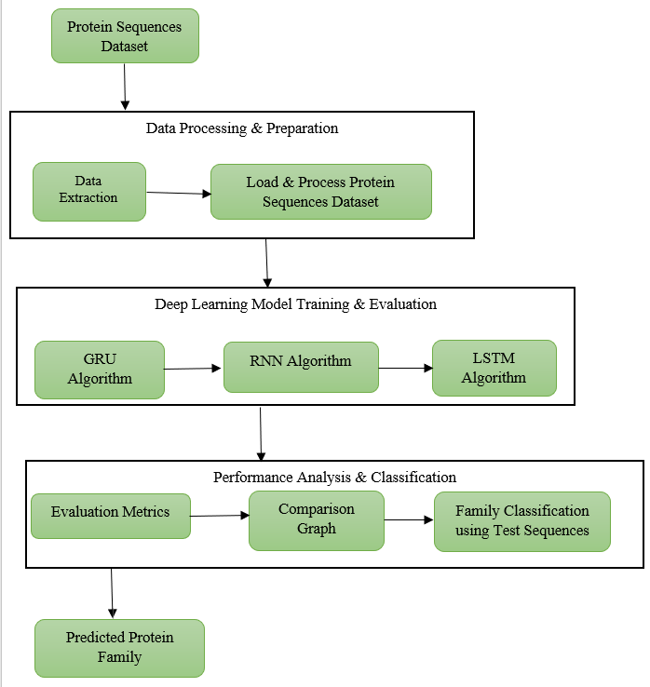
FIG 5.1 SYSTEM ARCHITECTURE

5.2 UML DIAGRAMS
The Unified Modelling Language allows the software engineer to express an analysis model using the modelling notation that is governed by a set of syntactic semantic and pragmatic rules.
A UML system is represented using five different views that describe the system from distinctly different perspective. Each view is defined by a set of diagram, which is as follows.
- User Model View
i.This view represents the system from the users perspective.
ii.The analysis representation describes a usage scenario from the end-users perspective.
- Structural Model view
i.In this model the data and functionality are arrived from inside the system.
ii.This model view models the static structures.
- Behavioural Model View
It represents the dynamic of behavioural as parts of the system, depicting the interactions of collection between various structural elements described in the user model and structural model view.
- Implementation Model View
In this the structural and behavioural as parts of the system are represented as they are to be built.
- Environmental Model View
In these the structural and behavioural aspects of the environment in which the system is to be implemented are represented.
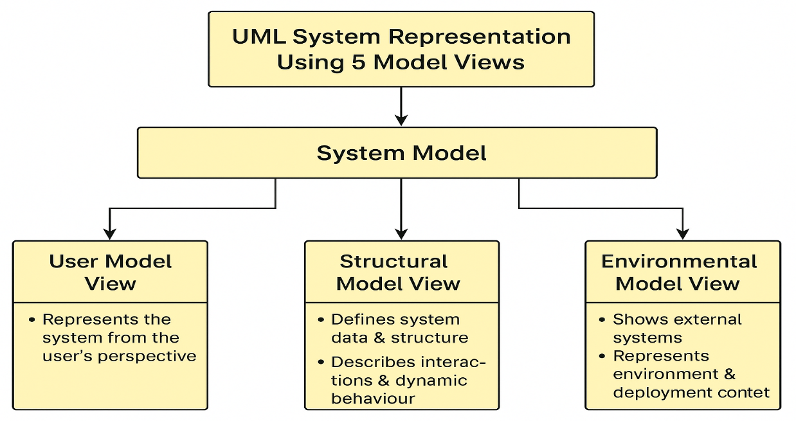 FIG 5.2 UML DIAGRAM

GOALS:
The Primary goals in the design of the UML are as follows:
- Provide users a ready-to-use, expressive visual modeling Language so that they can develop and exchange meaningful models.
- Provide extendibility and specialization mechanisms to extend the core concepts.
- Be independent of particular programming languages and development process.
- Provide a formal basis for understanding the modeling language.
- Encourage the growth of OO tools market.
- Support higher level development concepts such as collaborations, frameworks, patterns and components.
- Integrate best practices.

5.2.1 CLASS DIAGRAM
The class diagram is the main building block of object oriented modeling. It is used both for general conceptual modeling of the systematic of the application, and for detailed modeling translating the models into programming code. Class diagrams can also be used for data modeling. The classes in a class diagram represent both the main objects, interactions in the application and the classes to be programmed. In the diagram, classes are represented with boxes which contain three parts:
- The upper part holds the name of the class
- The middle part contains the attributes of the class
- The bottom part gives the methods or operations the class can take or undertake.
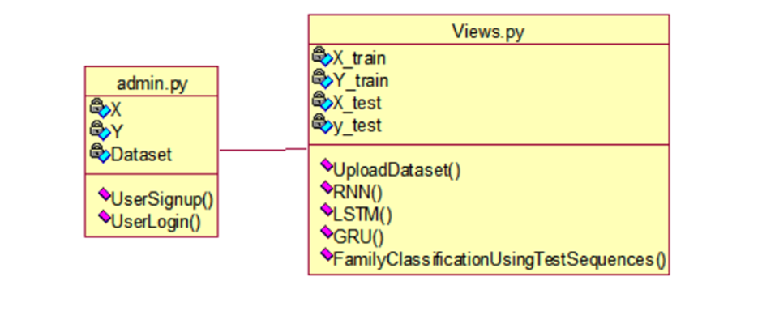
FIG 5.2.1 CLASS DIAGRAM

5.2.2 USE CASE DIAGRAM
A use case diagram at its simplest is a representation of a user's interaction with the system and depicting the specifications of a use case. A use case diagram can portray the different types of users of a system and the various ways that they interact with the system. This type of diagram is typically used in conjunction with the textual use case and will often be accompanied by other types of diagrams as well.

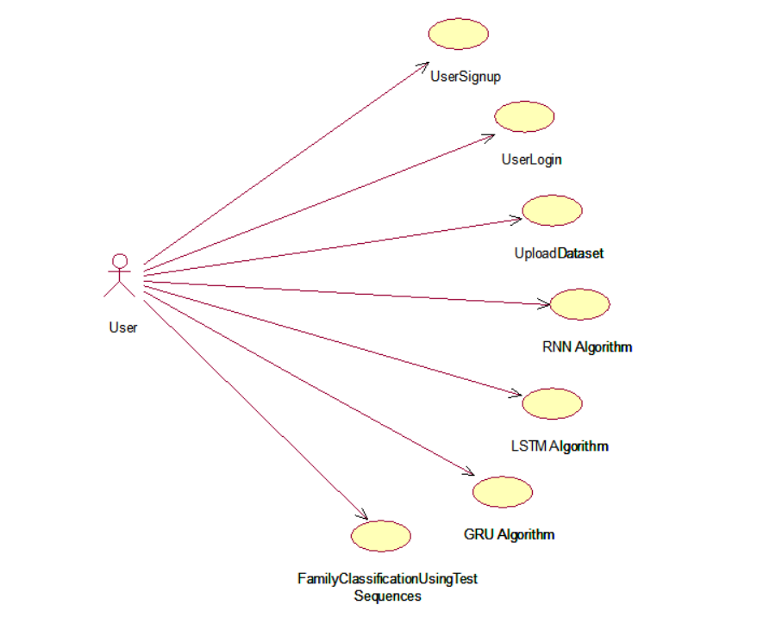
FIG 5.2.2 USE CASE DIAGRAM

5.2.3 SEQUENCE DIAGRAM
A sequence diagram is a kind of interaction diagram that shows how processes operate with one another and in what order. It is a construct of a Message Sequence Chart. A sequence diagram shows object interactions arranged in time sequence. It depicts the objects and classes involved in the scenario and the sequence of messages exchanged between the objects needed to carry out the functionality of the scenario. Sequence diagrams are typically associated with use case realizations in the Logical View of the system under development. Sequence diagrams are sometimes called event diagrams, event scenarios, and timing diagrams.
FIG 5.2.3 SEQUENCE DIAGRAM

5.2.4 ACTIVITY DIAGRAM
Activity diagrams are graphical representations of workflows of stepwise activities and actions with support for choice, iteration and concurrency. In the Unified Modeling Language, activity diagrams can be used to describe the business and operational step-by-step workflows of components in a system. An activity diagram shows the overall flow of control.
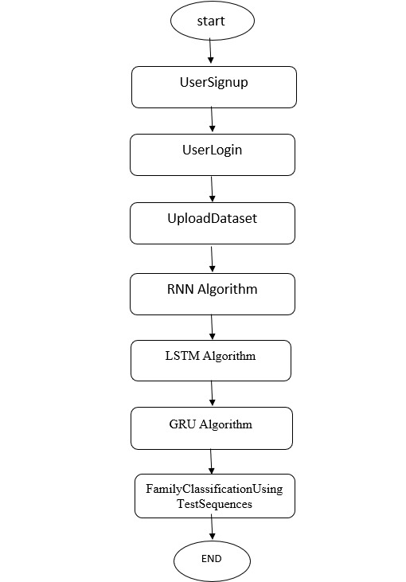
FIG 5.2.4 ACTIVITY DIAGRAM

5.2.5 DATA FLOW DIAGRAM
Data flow diagrams illustrate how data is processed by a system in terms of inputs and outputs. Data flow diagrams can be used to provide a clear representation of any business function. The technique starts with an overall picture of the business and continues by analyzing each of the functional areas of interest. This analysis can be carried out in precisely the level of detail required. The technique exploits a method called top-down expansion to conduct the analysis in a targeted way.
As the name suggests, Data Flow Diagram (DFD) is an illustration that explicates the passage of information in a process. A DFD can be easily drawn using simple symbols. Additionally, complicated processes can be easily automated by creating DFDs using easy-to-use, free downloadable diagramming tools. A DFD is a model for constructing and analyzing information processes. DFD illustrates the flow of information in a process depending upon the inputs and outputs. A DFD can also be referred to as a Process Model. A DFD demonstrates business or technical process with the support of the outside data saved, plus the data flowing from the process to another and the end results.

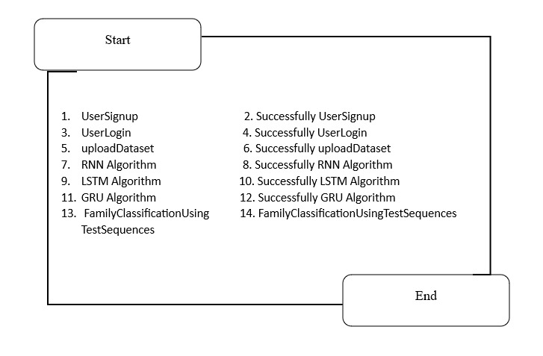
FIG 5.2.5 DATA FLOW DIAGRAM

5.2.6 COLLABORATION DIAGRAM
A collaboration diagram describes interactions among objects in terms of sequenced messages. Collaboration diagrams represent a combination of information taken from class, sequence, and use case diagrams describing both the static structure and dynamic behaviour of a system.

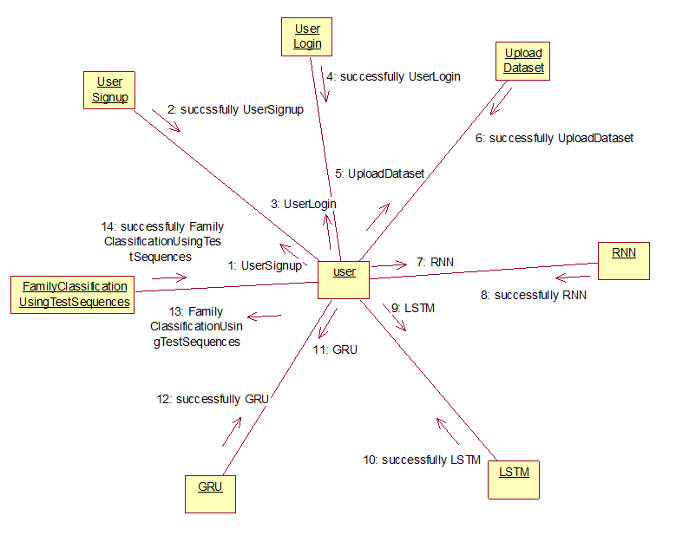
FIG 5.2.6 COLLABORATION DIAGRAM

5.2.7 COMPONENT DIAGRAM
In the Unified Modelling Language, a component diagram depicts how components are wired together to form larger components and or software systems. They are used to illustrate the structure of arbitrarily complex systems.
Components are wired together by using an assembly connector to connect the required interface of one component with the provided interface of another component. This illustrates the service consumer - service provider relationship between the two components.
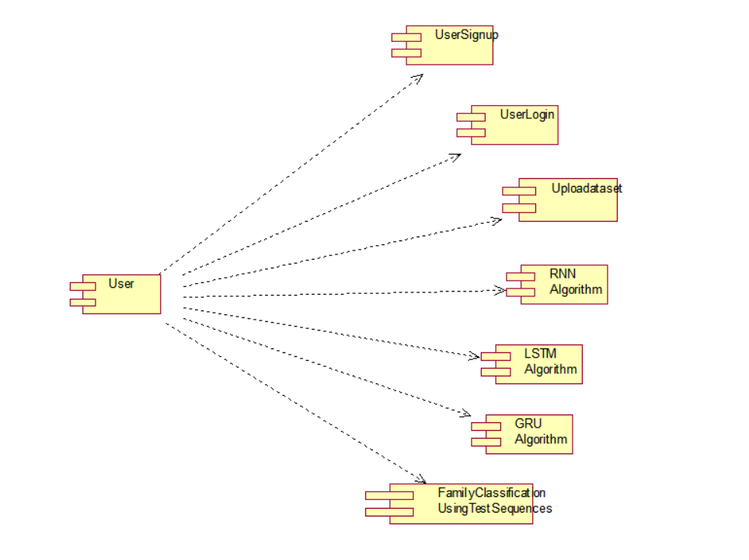
FIG 5.2.7 COMPONENT DIAGRAM

5.2.8 DEPLOYMENT DIAGRAM
A deployment diagram in the Unified Modelling Language models the physical deployment of artifacts on nodes. To describe a web site, for example, a deployment diagram would show what hardware components ("nodes") exist (e.g., a web server, an application server, and a database server), what software components ("artifacts") run on each node (e.g., web application, database), and how the different pieces are connected (e.g. JDBC, REST, RMI).
The nodes appear as boxes, and the artifacts allocated to each node appear as rectangles within the boxes. Nodes may have sub nodes, which appear as nested boxes. A single node in a deployment diagram may conceptually represent multiple physical nodes, such as a cluster of database servers.
FIG 5.2.8 DEPLOYMENT DIAGRAM

CHAPTER 6: IMPLEMENTATION

6. SYSTEM IMPLEMENTATIONS
The system implementation describes the practical development and execution of the protein family classification system using deep learning techniques. This phase focuses on building the model, processing the dataset, training the deep learning algorithms, and evaluating the performance of the system.
1. Data Collection
The first step in system implementation is collecting protein sequence data from reliable biological datasets. These datasets contain amino acid sequences along with their corresponding protein family labels. The collected dataset forms the foundation for training and testing the deep learning models.
2. Data Preprocessing
Before applying deep learning models, the raw protein sequence data must be preprocessed. This step involves cleaning the dataset, removing incomplete or irrelevant records, and converting amino acid sequences into numerical formats using encoding techniques. Proper preprocessing ensures that the data can be efficiently processed by the neural network models.
3. Feature Encoding and Representation
Protein sequences consist of amino acids represented by letters. Since machine learning models require numerical input, sequence encoding techniques are used to convert these characters into numerical representations. Techniques such as one-hot encoding or embedding representations are applied to preserve sequence information and patterns.
4. Model Development
In this stage, deep learning architectures are developed for protein classification. Models such as Recurrent Neural Networks (RNN), Long Short-Term Memory (LSTM), and Gated Recurrent Units (GRU) are implemented to capture sequential relationships within protein sequences. These models are designed to learn complex biological patterns from the dataset.
5. Model Training
The developed models are trained using the prepared dataset. During training, the neural network learns to recognize patterns that distinguish different protein families. Training involves multiple iterations where the model adjusts its parameters to minimize classification errors and improve prediction accuracy.
6. Model Evaluation
After training, the performance of the model is evaluated using a testing dataset. Several evaluation metrics such as accuracy, precision, recall, and F1-score are used to measure how effectively the system classifies protein families. These metrics help determine the reliability and efficiency of the model.
7. System Integration
The trained deep learning model is integrated into a functional system where users can input protein sequences and obtain classification results. This system can be implemented using programming tools and frameworks that support machine learning applications.
8. Result Visualization
The system provides visual representations of the results such as graphs, charts, and performance metrics. Visualization helps users easily understand the classification results and evaluate the effectiveness of the model.
9. Deployment Environment
The project is implemented using programming environments and tools such as Python, deep learning libraries, and cloud-based platforms like Google Colab. These platforms provide computational resources required for training deep learning models efficiently.

6.1 ADMIN MODULE:
The Admin Module is responsible for managing the overall operation of the system, ensuring data integrity, user management, and performance monitoring. The admin has elevated privileges and full control over the application’s backend processes.
- User Management:
The admin can view, verify, and manage all registered users. This includes monitoring user activity, approving new user registrations, and ensuring secure access control.
- Dataset Management:
The admin can upload, update, and maintain the protein sequence datasets used for training and testing. This includes validating the quality of datasets (e.g., from SideChainNet or Pfam) and ensuring that they are properly preprocessed and formatted for model training.
- Model Management:
The admin oversees the training of deep learning models such as RNN, LSTM, and GRU. They can initiate, monitor, and evaluate training processes, ensuring that models achieve high accuracy and reliability. The admin also manages the storage and retrieval of trained models for user predictions.
- Performance Evaluation:
The admin can analyze the performance of various models using metrics such as accuracy, precision, recall, and F1-score. Visualizations like graphs and confusion matrices help the admin compare models and select the best one for deployment.
- System Maintenance:
The admin ensures that all system modules are functioning properly, handles error logs, manages database backups, and maintains overall security. They can also update the platform to integrate new datasets, algorithms, or features.

6.2 USER MODULE:
The User Module is designed for researchers, students, and bioinformaticians who interact with the system to perform protein family classification tasks. It provides a simple and intuitive interface to carry out all essential operations, from registration to classification.
- Registration and Login:
Users can register by providing their details and create secure login credentials. Once verified by the admin, users can log in to access the system functionalities. This ensures a personalized and secure workspace for every user.
- Dataset Loading and Processing:
Users can upload protein sequence datasets or select existing datasets from the database. The system automatically processes the sequences, extracts features, and splits the data into training and testing sets. Feature extraction is accelerated using GPU-enabled processing for efficiency.
- Model Training:
Users can select from multiple deep learning models - RNN, LSTM, or GRU - to train on the dataset. They can monitor training progress, view accuracy graphs, and evaluate the model’s performance using key metrics. The trained model is saved for later testing or classification.
- Protein Family Classification:
Users can upload test sequences to identify their respective protein families. The system uses the best-performing trained model to classify these sequences and display the results, including the predicted family and confidence score.
- Performance Analysis and Visualization:
Users can view the classification results through graphs, performance metrics, and confusion matrices, helping them understand model efficiency and accuracy in biological terms.

6.3 TECHNOLOGIES AND ALGORITHMS USED
The development of the Protein Family Classification using Deep Learning Techniques project involves several technologies, programming tools, and machine learning algorithms. These technologies enable efficient data processing, model development, training, and evaluation for accurate protein classification.

1. Programming Language – Python
Python is the primary programming language used for implementing the project. It provides a simple syntax and a large number of libraries that support machine learning, data analysis, and scientific computing. Python is widely used in bioinformatics and artificial intelligence applications due to its flexibility and extensive community support.

2. Deep Learning Framework – TensorFlow / Keras
TensorFlow and Keras are powerful deep learning frameworks used to build and train neural network models. These frameworks provide pre-built functions and modules for designing deep learning architectures such as RNN, LSTM, and GRU. They also support GPU acceleration, which helps in faster model training.

3. Data Processing Libraries
Several Python libraries are used for data preprocessing and manipulation:
- NumPy – Used for numerical computations and handling multidimensional arrays.
- Pandas – Used for data cleaning, manipulation, and dataset handling.
- Matplotlib / Seaborn – Used for visualizing data, graphs, and model performance results.

4. Development Environment – Google Colab / Jupyter Notebook
The project is implemented using platforms such as Google Colab or Jupyter Notebook, which provide an interactive environment for coding, testing, and training machine learning models. These environments also offer GPU support for faster computation.

5. Dataset
Protein sequence datasets are used as the primary input for the model. The dataset contains amino acid sequences and their corresponding protein family labels. These datasets are processed and encoded before being used for model training and testing.

6. Algorithms Used

Recurrent Neural Network (RNN)
RNN is a type of neural network designed to handle sequential data. It processes sequences step by step and retains information from previous inputs. RNN is suitable for analyzing protein sequences because amino acid sequences follow a specific order.

Long Short-Term Memory (LSTM)
LSTM is an advanced form of RNN designed to overcome the limitations of traditional RNNs, particularly the vanishing gradient problem. LSTM networks can capture long-term dependencies in sequential data, making them highly effective for biological sequence analysis.

Gated Recurrent Unit (GRU)
GRU is another variant of RNN that simplifies the structure of LSTM while maintaining similar performance. It uses gating mechanisms to control information flow and efficiently learn patterns in sequence data.

7. Evaluation Metrics
To measure the performance of the classification models, several evaluation metrics are used:
- Accuracy – Measures the overall correctness of the model.
- Precision – Indicates how many predicted classifications are correct.
- Recall – Measures the ability of the model to correctly identify protein families.
- F1-Score – Provides a balance between precision and recall.

6.4 SOURCE CODE:
from django.shortcuts import render
from django.template import RequestContext
from django.contrib import messages
from django.http import HttpResponse
from django.conf import settings
import os
import io
import base64
import matplotlib.pyplot as plt
import pandas as pd
import numpy as np
from sklearn.model_selection import train_test_split
from sklearn.metrics import accuracy_score
from sklearn.metrics import f1_score
from sklearn.metrics import precision_score
from sklearn.metrics import recall_score
import seaborn as sns
from sklearn.metrics import confusion_matrix
import os
import cv2
import pymysql
from keras.callbacks import ModelCheckpoint
import pickle
from keras.layers import LSTM, SimpleRNN, GRU #load LSTM class
from keras.utils.np_utils import to_categorical
from keras.layers import Dense, Dropout, Activation, Flatten
from keras.models import Sequential, Model, load_model
from sklearn.model_selection import train_test_split
from keras.models import Sequential
from sklearn.preprocessing import StandardScaler

global username
global X_train, X_test, y_train, y_test, X, families, labels, scaler
accuracy = []
precision = []
recall = []
fscore = []
path = "Dataset"

#function to calculate all metrics
def calculateMetrics(algorithm, y_test, predict):
a = (accuracy_score(y_test,predict)*100)
p = (precision_score(y_test, predict,average='macro') * 100)
r = (recall_score(y_test, predict,average='macro') * 100)
f = (f1_score(y_test, predict,average='macro') * 100)
a = round(a, 3)
p = round(p, 3)
r = round(r, 3)
f = round(f, 3)
accuracy.append(a)
precision.append(p)
recall.append(r)
fscore.append(f)
return algorithm

labels = ['Globins', 'Serine Proteases Trypsin Family', 'Immunoglobulin V-set Domain', 'TIM Barrel']

sequences = np.load("Dataset/seq.npy")
families = np.load("Dataset/families.npy")
angles = np.load("Dataset/angles.npy")
scaler = StandardScaler()
sequences = scaler.fit_transform(sequences)

indices = np.arange(sequences.shape[0])
np.random.shuffle(indices)
sequences = sequences[indices]
families = families[indices]
families = to_categorical(families)

X = np.reshape(sequences, (sequences.shape[0], 80, 50))

X_train, X_test, y_train, y_test = train_test_split(X, families, test_size=0.3) #split dataset into train and test

#train RNN algorithm on training data and utilize test data to calculate RNN performance
rnn_model = Sequential()
#adding RNN layer with 32 nuerons to filter features 32 time
rnn_model.add(SimpleRNN(32, input_shape=(X_train.shape[1], X_train.shape[2]), return_sequences=True))
rnn_model.add(Activation('relu'))
#dropout layer to remove irrrelevant features from dataset
rnn_model.add(Dropout(0.5))
#adding another RNN layer with 16 neurons
rnn_model.add(SimpleRNN(16))
rnn_model.add(Dropout(0.5))
#defining output layer
rnn_model.add(Dense(units = 256, activation = 'relu'))
rnn_model.add(Dense(units = y_train.shape[1], activation = 'softmax'))
rnn_model.compile(optimizer = 'adam', loss = 'categorical_crossentropy', metrics = ['accuracy'])
if os.path.exists("model/rnn_weights.hdf5") == False:
model_check_point = ModelCheckpoint(filepath='model/rnn_weights.hdf5', verbose = 1, save_best_only = True)
hist = rnn_model.fit(X_train, y_train, batch_size = 32, epochs = 30, validation_data=(X_test, y_test), callbacks=[model_check_point], verbose=1)
f = open('model/rnn_history.pckl', 'wb')
pickle.dump(hist.history, f)
f.close()
else:
rnn_model.load_weights("model/rnn_weights.hdf5")
predict = rnn_model.predict(X_test)
predict = np.argmax(predict, axis=1)
y_test1 = np.argmax(y_test, axis=1)
#call this function to calculate accuracy and other metrics
calculateMetrics("RNN", y_test1, predict)
conf_matrix = confusion_matrix(y_test1, predict)

#train LSTM algorithm on training data and utilize test data to calculate LSTM performance
lstm_model = Sequential()
#adding LSTM layer with 32 nuerons to filter features 32 time
lstm_model.add(LSTM(32, input_shape=(X_train.shape[1], X_train.shape[2]), return_sequences=True))
lstm_model.add(Activation('relu'))
#dropout layer to remove irrrelevant features from dataset
lstm_model.add(Dropout(0.5))
#adding another LSTM layer with 16 neurons
lstm_model.add(LSTM(16))
lstm_model.add(Dropout(0.5))
#defining output layer
lstm_model.add(Dense(units = 256, activation = 'relu'))
lstm_model.add(Dense(units = y_train.shape[1], activation = 'softmax'))
lstm_model.compile(optimizer = 'adam', loss = 'categorical_crossentropy', metrics = ['accuracy'])
if os.path.exists("model/lstm_weights.hdf5") == False:
model_check_point = ModelCheckpoint(filepath='model/lstm_weights.hdf5', verbose = 1, save_best_only = True)
hist = lstm_model.fit(X_train, y_train, batch_size = 32, epochs = 30, validation_data=(X_test, y_test), callbacks=[model_check_point], verbose=1)
f = open('model/lstm_history.pckl', 'wb')
pickle.dump(hist.history, f)
f.close()
else:
lstm_model.load_weights("model/lstm_weights.hdf5")

predict = lstm_model.predict(X_test)
predict = np.argmax(predict, axis=1)
y_test1 = np.argmax(y_test, axis=1)
#call this function to calculate accuracy and other metrics
calculateMetrics("LSTM", y_test1, predict)

#train GRU algorithm on training data and utilize test data to calculate GRU performance
gru_model = Sequential()
#adding GRU layer with 32 nuerons to filter features 32 time
gru_model.add(GRU(32, input_shape=(X_train.shape[1], X_train.shape[2]), return_sequences=True))
gru_model.add(Activation('relu'))
#dropout layer to remove irrrelevant features from dataset
gru_model.add(Dropout(0.5))
#adding another GRU layer with 16 neurons
gru_model.add(GRU(16))
gru_model.add(Dropout(0.5))
#defining output layer
gru_model.add(Dense(units = 256, activation = 'relu'))
gru_model.add(Dense(units = y_train.shape[1], activation = 'softmax'))
gru_model.compile(optimizer = 'adam', loss = 'categorical_crossentropy', metrics = ['accuracy'])
if os.path.exists("model/gru_weights.hdf5") == False:
model_check_point = ModelCheckpoint(filepath='model/gru_weights.hdf5', verbose = 1, save_best_only = True)
hist = gru_model.fit(X_train, y_train, batch_size = 32, epochs = 30, validation_data=(X_test, y_test), callbacks=[model_check_point], verbose=1)
f = open('model/gru_history.pckl', 'wb')
pickle.dump(hist.history, f)
f.close()
else:
gru_model.load_weights("model/gru_weights.hdf5")

predict = gru_model.predict(X_test)
predict = np.argmax(predict, axis=1)
y_test1 = np.argmax(y_test, axis=1)
#call this function to calculate accuracy and other metrics
calculateMetrics("GRU", y_test1, predict)

def getModel():
#train RNN algorithm on training data and utilize test data to calculate RNN performance
rnn_model = Sequential()
#adding RNN layer with 32 nuerons to filter features 32 time
rnn_model.add(SimpleRNN(32, input_shape=(X_train.shape[1], X_train.shape[2]), return_sequences=True))
rnn_model.add(Activation('relu'))
#dropout layer to remove irrrelevant features from dataset
rnn_model.add(Dropout(0.5))
#adding another RNN layer with 16 neurons
rnn_model.add(SimpleRNN(16))
rnn_model.add(Dropout(0.5))
#defining output layer
rnn_model.add(Dense(units = 256, activation = 'relu'))
rnn_model.add(Dense(units = y_train.shape[1], activation = 'softmax'))
rnn_model.compile(optimizer = 'adam', loss = 'categorical_crossentropy', metrics = ['accuracy'])
rnn_model.load_weights("model/rnn_weights.hdf5")
return rnn_model

def Predict(request):
if request.method == 'GET':
return render(request, 'Predict.html', {})

def PredictAction(request):
if request.method == 'POST':
global labels, angles
rnn_model = getModel()
myfile = request.FILES['t1'].read()
if os.path.exists('ProteinApp/static/test.npy'):
os.remove('ProteinApp/static/test.npy')
with open('ProteinApp/static/test.npy', "wb") as file:
file.write(myfile)
file.close()
sequences = np.load("ProteinApp/static/test.npy")
seq = sequences.copy()
sequences = scaler.transform(sequences)
sequences = np.reshape(sequences, (sequences.shape[0], 80, 50))
predict = rnn_model.predict(sequences)
result='<table border=1 align=center width=100%><tr><th><font size="3" color="black">Test Sequences</th><th><font size="3" color="black">Predicted Family</th></tr>'
for i in range(len(predict)):
pred = np.argmax(predict[i])
result += '<td><font size="3" color="black">'+str(seq[i][0:50])+'</td><td><font size="4" color="blue">'+labels[pred]+'</td></tr>'
result+= "</table></br>"
data = angles[0]
fig, ax1 = plt.subplots(1, 1, figsize=(8, 3), sharex=True)
ax1.plot(data[:, 0], 'b-', label='Phi (φ)')
ax1.plot(data[:, 1], 'r-', label='Psi (ψ)')
ax1.plot(data[:, 2], 'g-', label='Omega (ω)')
ax1.set_ylabel('Angle (radians)')
ax1.set_title('Backbone Torsion Angles')
ax1.legend()
ax1.grid(True)
plt.tight_layout()
buffer = io.BytesIO()
plt.savefig(buffer,format='png',bbox_inches='tight')
image_b64 = base64.b64encode(buffer.getvalue()).decode()
plt.clf()
plt.cla()
context= {'data':result, 'img': image_b64}
return render(request, 'UserScreen.html', context)

def TrainModel(request):
if request.method == 'GET':
global X_train, X_test, y_train, y_test, labels
global accuracy, precision, recall, fscore, conf_matrix
result='<table border=1 align=center width=100%><tr><th><font size="3" color="black">Algorithm Name</th><th><font size="3" color="black">Accuracy</th>'
result += '<th><font size="3" color="black">Precision</th><th><font size="3" color="black">Recall</th><th><font size="3" color="black">FSCORE</th></tr>'
algorithms = ['RNN', 'LSTM', 'GRU']
for i in range(len(algorithms)):
result += '<td><font size="3" color="black">'+algorithms[i]+'</td><td><font size="3" color="black">'+str(accuracy[i])+'</td><td><font size="3" color="black">'+str(precision[i])+'</td>'
result += '<td><font size="3" color="black">'+str(recall[i])+'</td><td><font size="3" color="black">'+str(fscore[i])+'</td></tr>'
result+= "</table></br>"
figure, axes = plt.subplots(nrows=1, ncols=2,figsize=(10, 3))
axes[0].set_title("RNN Confusion Matrix Graph")
axes[1].set_title("Comparison Graph")
ax = sns.heatmap(conf_matrix,xticklabels=labels,yticklabels=labels,annot=True,cmap="viridis",fmt="g", ax=axes[0]);
ax.set_ylim([0,len(labels)])
dframe = pd.DataFrame([['RNN','Accuracy',accuracy[0]],['RNN','Precision',precision[0]],['RNN','Recall',recall[0]],['RNN','FSCORE',fscore[0]],
['LSTM','Accuracy',accuracy[1]],['LSTM','Precision',precision[1]],['LSTM','Recall',recall[1]],['LSTM','FSCORE',fscore[1]],
['GRU','Accuracy',accuracy[2]],['GRU','Precision',precision[2]],['GRU','Recall',recall[2]],['GRU','FSCORE',fscore[2]],
],columns=['Parameters','Algorithms','Value'])
dframe.pivot("Parameters", "Algorithms", "Value").plot(kind='bar', ax=axes[1])
buffer = io.BytesIO()
plt.savefig(buffer,format='png',bbox_inches='tight')
image_b64 = base64.b64encode(buffer.getvalue()).decode()
plt.clf()
plt.cla()
context= {'data':result, 'img': image_b64}
return render(request, 'UserScreen.html', context)

def LoadDataset(request):
if request.method == 'GET':
global X_train, X_test, y_train, y_test, X, Y, labels
output = '<font size="3" color="black">Protein Sequences Dataset Loaded</font><br/>'
output += '<font size="3" color="blue">Total Sequences found in Dataset = '+str(X.shape[0])+'</font><br/>'
output += '<font size="3" color="blue">Number of features found in each Sequence = '+str(X.shape[1])+'</font><br/>'
output += '<font size="3" color="blue">Different Families Labels found in Dataset = '+str(labels)+'</font><br/><br/>'
output += '<font size="3" color="black">Dataset Train & Test Split details</font><br/>'
output += '<font size="3" color="blue">80% dataset sequences used to train DL Algorithms = '+str(X_train.shape[0])+'</font><br/>'
output += '<font size="3" color="blue">20% dataset sequences used to test DL Algorithms = '+str(X_test.shape[0])+'</font><br/>'
context= {'data':output}
return render(request, 'UserScreen.html', context)

def RegisterAction(request):
if request.method == 'POST':
global username
username = request.POST.get('t1', False)
password = request.POST.get('t2', False)
contact = request.POST.get('t3', False)
email = request.POST.get('t4', False)
address = request.POST.get('t5', False)
output = "none"
con = pymysql.connect(host='127.0.0.1',port = 3306,user = 'root', password = 'root', database = 'protein',charset='utf8')
with con:
cur = con.cursor()
cur.execute("select username FROM register")
rows = cur.fetchall()
for row in rows:
if row[0] == username:
output = username+" Username already exists"
break
if output == "none":
db_connection = pymysql.connect(host='127.0.0.1',port = 3306,user = 'root', password = 'root', database = 'protein',charset='utf8')
db_cursor = db_connection.cursor()
student_sql_query = "INSERT INTO register(username,password,contact,email,address) VALUES('"+username+"','"+password+"','"+contact+"','"+email+"','"+address+"')"
db_cursor.execute(student_sql_query)
db_connection.commit()
print(db_cursor.rowcount, "Record Inserted")
if db_cursor.rowcount == 1:
output = "Signup process completed. Login to perform Protein Family Classification"
context= {'data':output}
return render(request, 'Register.html', context)

def UserLoginAction(request):
global username
if request.method == 'POST':
global username
status = "none"
users = request.POST.get('t1', False)
password = request.POST.get('t2', False)
con = pymysql.connect(host='127.0.0.1',port = 3306,user = 'root', password = 'root', database = 'protein',charset='utf8')
with con:
cur = con.cursor()
cur.execute("select username,password FROM register")
rows = cur.fetchall()
for row in rows:
if row[0] == users and row[1] == password:
username = users
status = "success"
break
if status == 'success':
context= {'data':'Welcome '+username}
return render(request, "UserScreen.html", context)
else:
context= {'data':'Invalid username'}
return render(request, 'UserLogin.html', context)
def UserLogin(request):
if request.method == 'GET':
return render(request, 'UserLogin.html', {})
def index(request):
if request.method == 'GET':
return render(request, 'index.html', {})
def Register(request):
if request.method == 'GET':
return render(request, 'Register.html', {})

CHAPTER 7 :TESTING

7. TESTING
Testing is an essential phase in the development of the Protein Family Classification System using Deep Learning Techniques. It ensures that the trained deep learning models perform accurately, efficiently, and reliably when classifying protein sequences into their respective families. Since biological sequence data can be large and complex, proper testing is required to verify the correctness of data processing, model training, and prediction outputs.

7.1 Purpose of Testing
The main objectives of testing the system are:
- To evaluate the performance of the trained deep learning models.
- To ensure that the system correctly classifies protein sequences into their respective families.
- To verify the accuracy and reliability of the data preprocessing and sequence encoding methods.
- To minimize classification errors such as incorrect protein family predictions.
- To validate the overall stability and efficiency of the system before final deployment.

7.2 Types of Testing Performed

7.2.1 Unit Testing
Unit testing focuses on testing individual components of the system to ensure that each module works correctly.Modules tested include:
- Dataset loading and preprocessing module
- Protein sequence encoding module
- Deep learning model architecture implementation
- Model training functions
- Prediction module
Each component was tested independently to verify correct functionality before integration.
7.2.2 Integration Testing
Integration testing ensures that different modules of the system work correctly when combined together.
Modules tested include:
- Data preprocessing + sequence encoding
- Encoded dataset + deep learning model training
- Trained model + prediction system
Workflow tested:
Protein Sequence → Data Preprocessing → Deep Learning Model → Protein Family Prediction
7.2.3 System Testing
System testing evaluates the entire protein classification system as a complete workflow.
Complete system process tested:
Protein Sequence Input → Data Processing → Sequence Encoding → Deep Learning Model → Protein Family Classification Output
This testing verifies that all modules interact correctly and produce the expected results.
7.2.4 Model Validation Testing
To ensure the reliability of the deep learning model, the dataset was divided into training and testing sets.
Typical split used:
- Training Set: 80%
- Testing Set: 20%
Cross-validation techniques were also used to evaluate the model’s generalization ability and ensure stable performance across different subsets of the dataset.

7.3 Performance Testing
To evaluate the effectiveness of the protein classification model, several performance metrics were used:
Accuracy: Measures the overall percentage of correctly classified protein sequences.
Precision: Indicates the proportion of correctly predicted protein family classifications out of all predicted classifications.
Recall: Measures the ability of the model to correctly identify protein sequences belonging to a specific family.
F1-Score: The harmonic mean of precision and recall, providing a balanced measure of model performance.
Confusion matrix: Displays the number of correct and incorrect predictions for each protein family class.
These metrics help determine how well the deep learning model performs in classifying protein sequences.

7.4 Testing Results (Sample Format)
Model | Accuracy | Precision | Recall | F1-Score
RNN | 95.4 | 94.1 | 94.4 | 94.2
LSTM | 94.2 | 93.2 | 91.6 | 92.2
GRU | 93.5 | 92.1 | 90.8 | 91.3
Among the implemented models, LSTM showed better performance in capturing long-term dependencies within protein sequences and achieved higher classification accuracy.

7.5 Error Analysis
During testing, two types of errors were analyzed:
Misclassification Errors
Some protein sequences were incorrectly classified into the wrong protein family due to sequence similarity between families.
Data Representation Limitations
Certain protein sequences may not contain enough distinguishing features, making classification more challenging.
Efforts were made to improve performance through better sequence encoding and model tuning.

7.6 Conclusion of Testing
The testing phase confirms that deep learning models can effectively classify protein sequences into their respective families with high accuracy. Among the tested models, sequence-based architectures such as LSTM and GRU performed better due to their ability to capture sequential dependencies in biological data.
The results demonstrate that deep learning provides a reliable and scalable solution for protein family classification and can support bioinformatics research in analyzing large biological datasets.

CHAPTER 8: RESULT
8.RESULT
Protein Family Classification using Deep Learning Techniques
In propose work we are employing deep learning algorithms such as GRU, RNN and LSTM to predict family from protein sequences. To train above models we have used Protein Sequences dataset from SideChainNet which can be downloaded and processes using below code
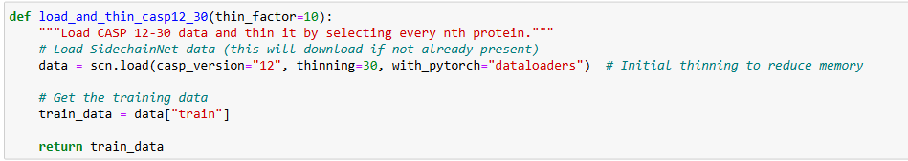
Above block of code will load CASP protein sequences dataset using 12 version
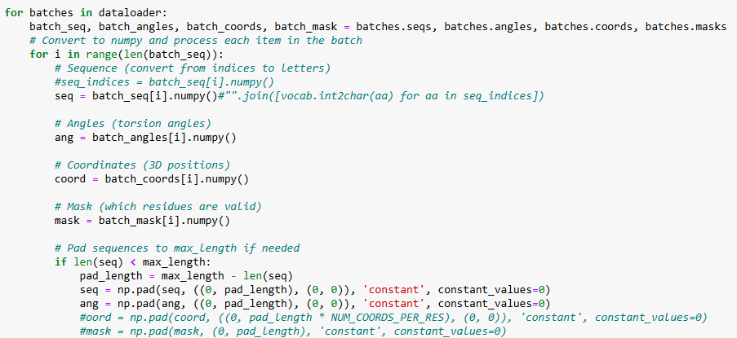Above block of code used to extract sequences, coordinates and angles from CASP sequences batch dataset. All extracted sequences can be input to DL algorithms to train a model and this trained model can be applied on test sequences to calculate prediction accuracy.
We have extracted all features and then saved those features in Dataset folder as NUMPY format. We cannot load and process above dataset in NORMAL CPU system so we need to load and extract features from Google COLAB GPU and then can save those features in NUMPY and reuse those features for training with DL algorithms in normal CPU.
Each DL algorithm performance is evaluated in terms of accuracy, precision, recall and FSCORE.
To implement this project we have designed following modules
- Registration Here: user can sign up with the application
- User Login: user can login to system
- Load & Process Protein Sequences Dataset: using this model will load and normalize all dataset sequences and then split into train and test where application using 80% sequences for training and 20% for testing
- Train DL Algorithms: 80% training sequences will be input to DL algorithms to trained a model and this model will be applied on 20% test sequences to calculate prediction accuracy
- Family Classification using Test Sequences: using this module user can upload test sequences and then best performing DL model will classify type of family.

SCREEN SHOTS
Install python 3.7.2 and then install all packages given in requirements.txt file and then install MYSQL database and then copy content from ‘database.txt file and then paste in MYSQL console to create database
To run project double click on ‘run.bat’ file to start python server and then will get below page

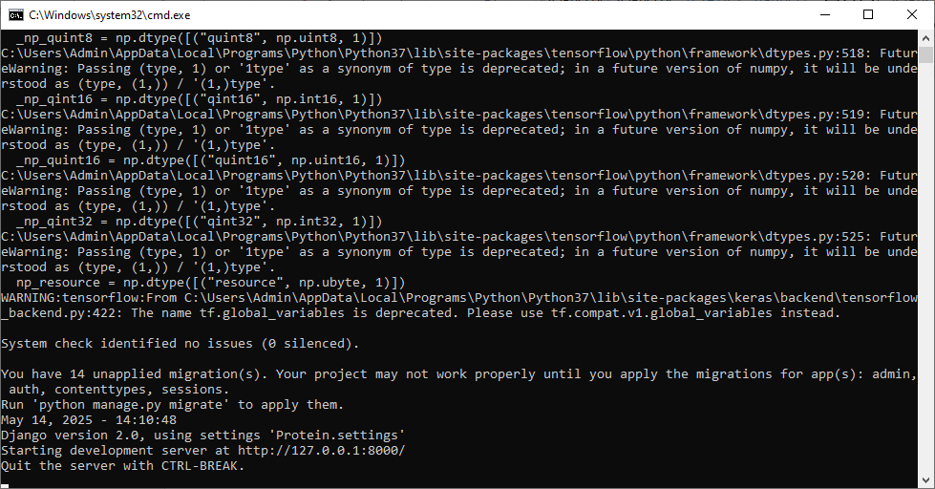
FIG 8.1 PYTHON SERVER STARTED
In above screen python server started and now open browser and enter URL as http://127.0.0.1:8000/index.html and then press enter key to get below page
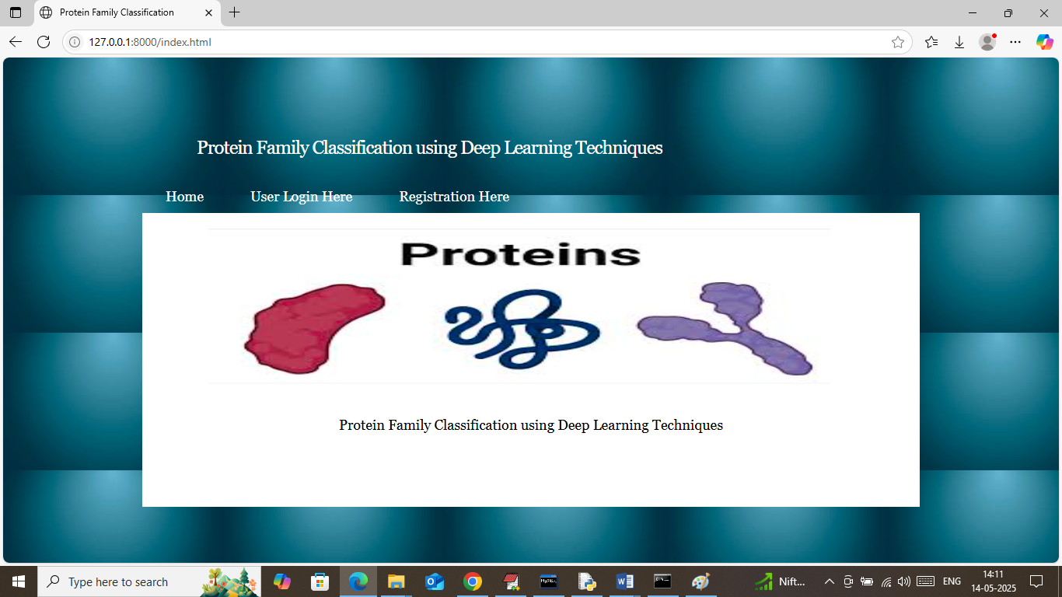
FIG 8.2 NEW USER REGISTER
In above screen click on ‘Registration Here’ link to get below page
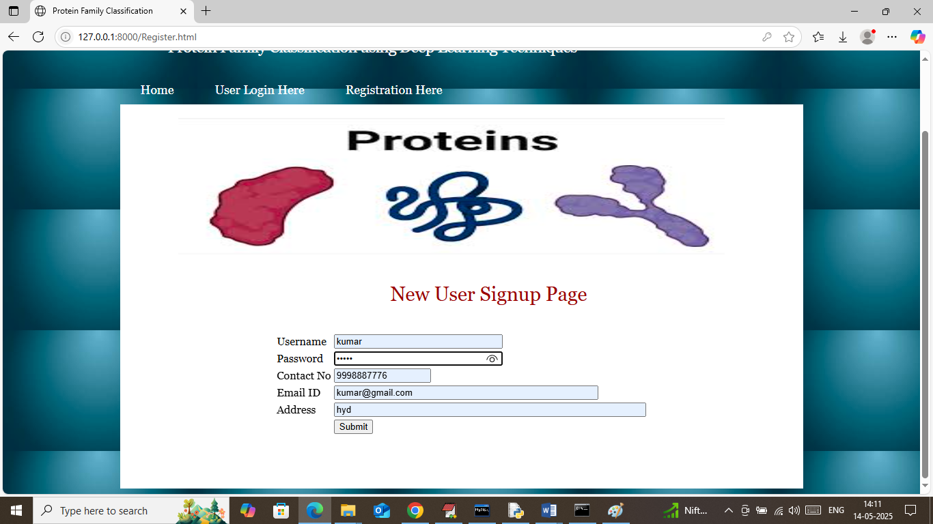
FIG 8.3 ENTERING SIGN UP DETAILS
In above screen user is entering sign up details and then press button to get below page
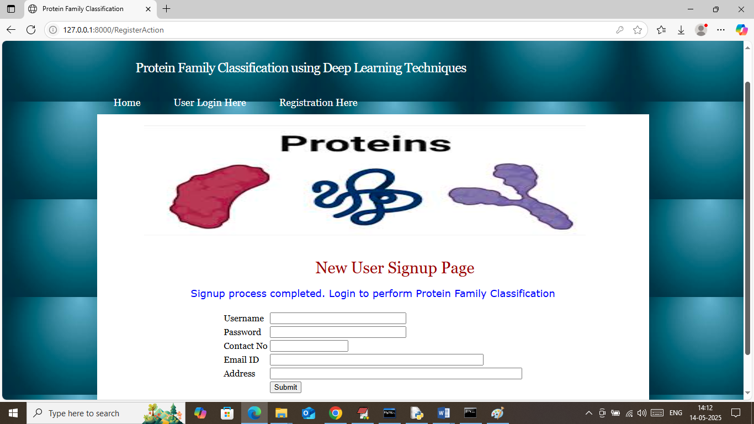
FIG 8.4 USER LOGIN DONE
In above screen user sign up process completed and now click on ‘User Login Here’ link to get below page
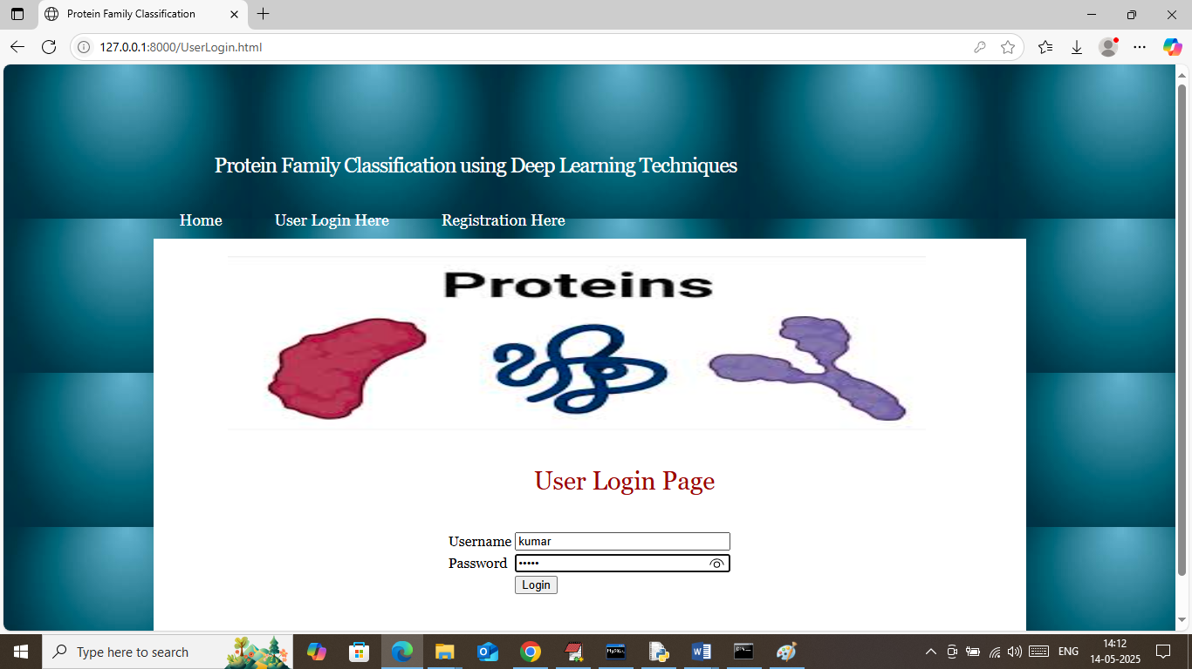
FIG 8.5 LOGIN
In above screen user is login and after login will get below page
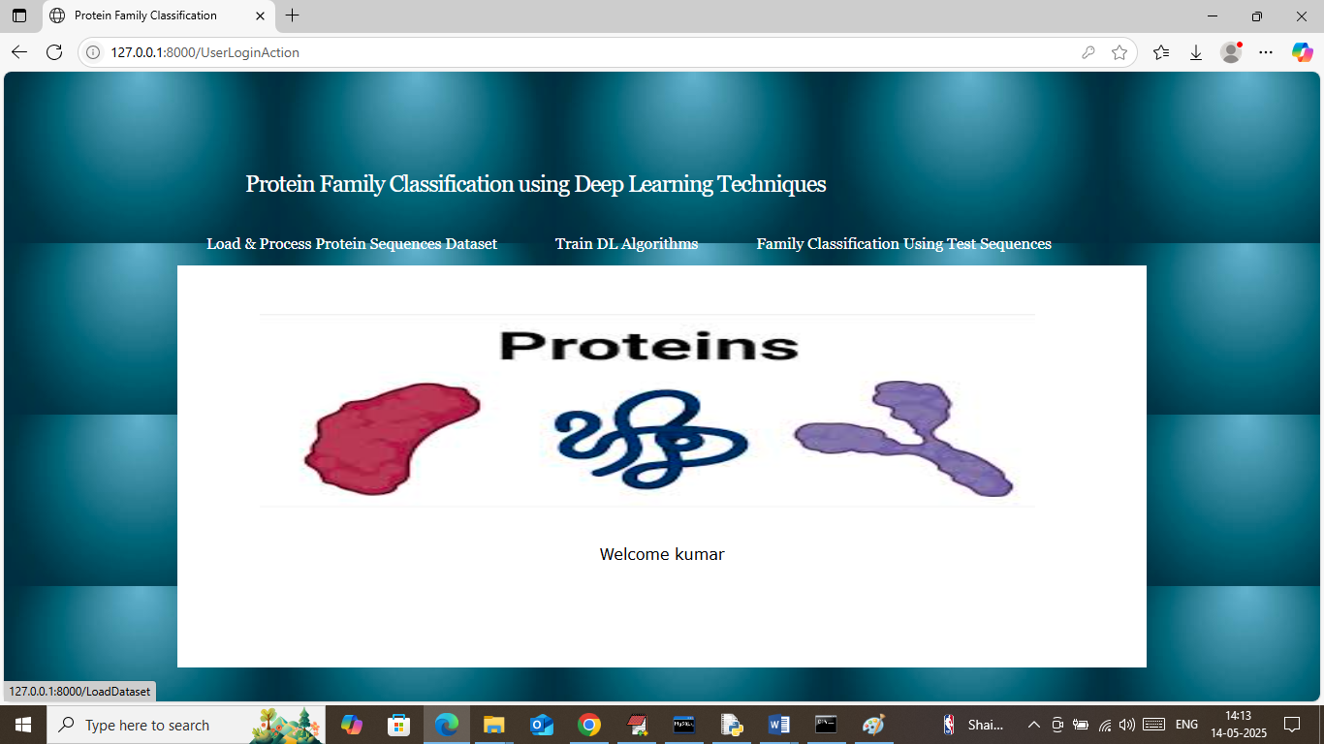
FIG 8.6 LOAD & PROCESSED DATASET
In above screen user can click on ‘Load & Process Protein Sequences Dataset’ link to load dataset and then will get below page
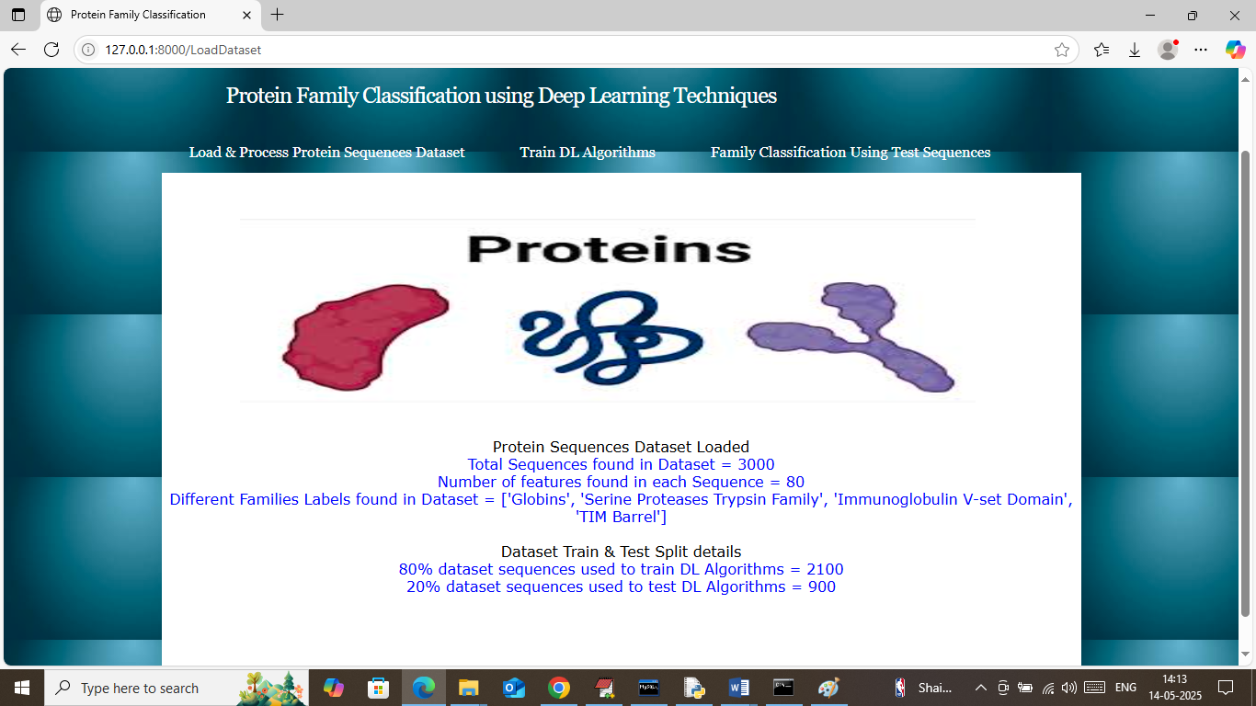
FIG 8.7 IN ABOVE SCREEN DATASET LOADED
In above screen can see number of sequences loaded and processed from dataset and can see number of features available in each sequences and then can different families class labels found in dataset and then can see train and test size. Now click on ‘Train DL Algorithms’ link to train DL algorithms and then will get below page.
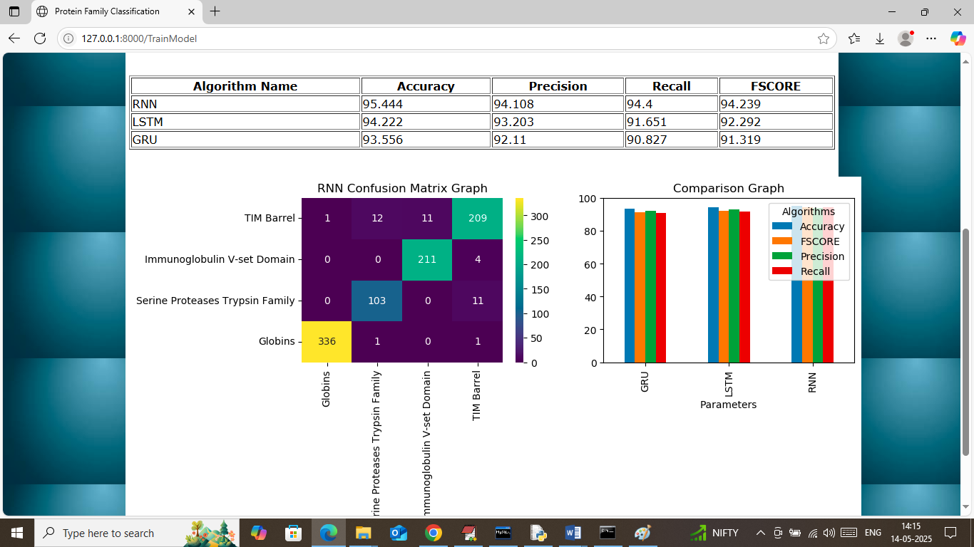
FIG 8.8 TRAINING RECORDS
In above screen in table format can see LSTM, RNN and GRU algorithms performance where RNN got 95% accuracy and LSTM got 94% and GRU got 93% accuracy and can see other metrics like precision, recall and FSCORE. In confusion matrix graph x-axis represents ‘Predicted Family Labels’ and y-axis represents True labels and then different colour boxes in diagonal represents correct prediction count and remaining blue boxes represents incorrect prediction count which are very few. In second graph showing comparison graph between all algorithms where x-axis represents algorithm names and y-axis represents accuracy and other metrics in different colour bars. Now click on ‘Family Classification using Test Sequences’ link to get below page
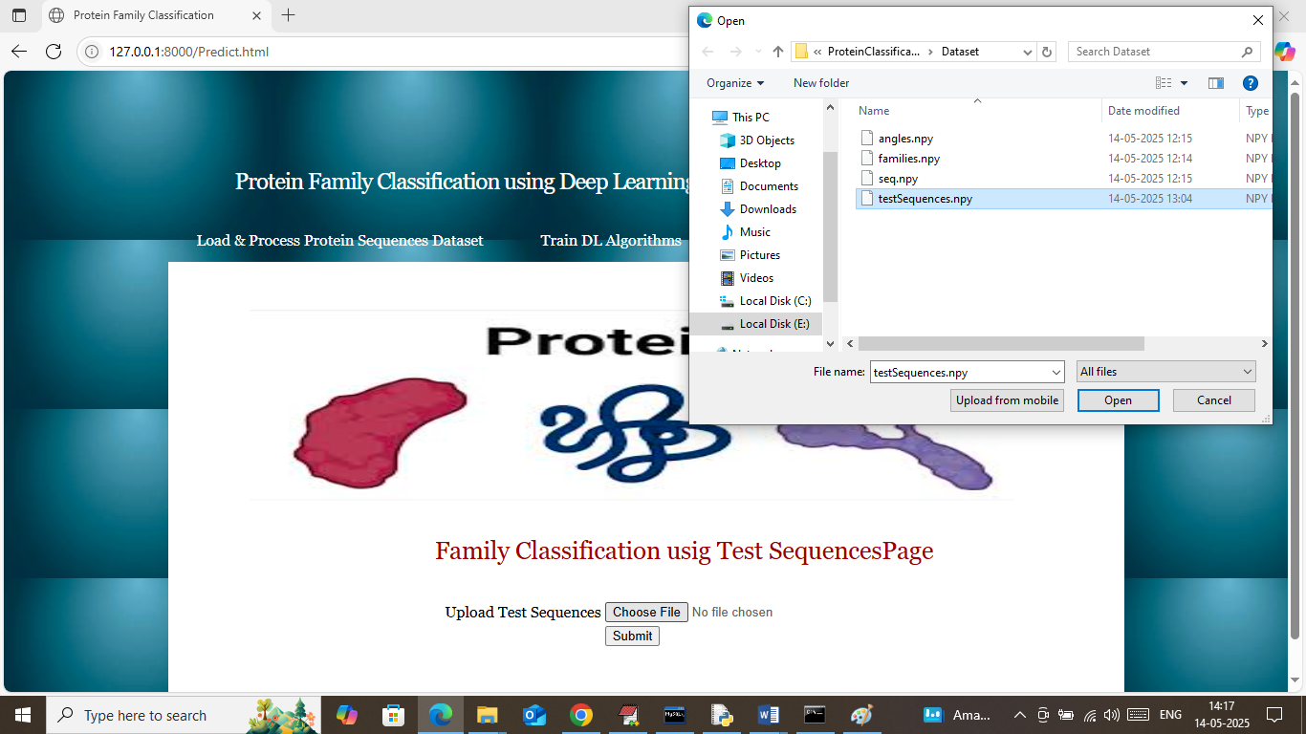
FIG 8.9 SELECTING AND UPLOADING ‘TESTSEQUENCES.NPY’ FILE
In above screen selecting and uploading test sequences file and then click on buttons to get below page
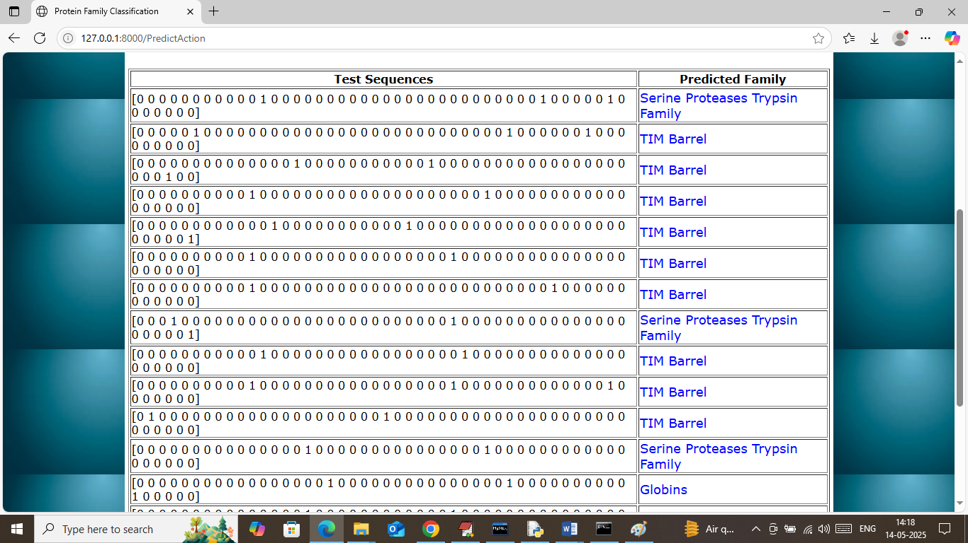
FIG 8.10 TEST DATA VALUES
In above screen in first column showing few sequences from test data and in second column displaying classified family name
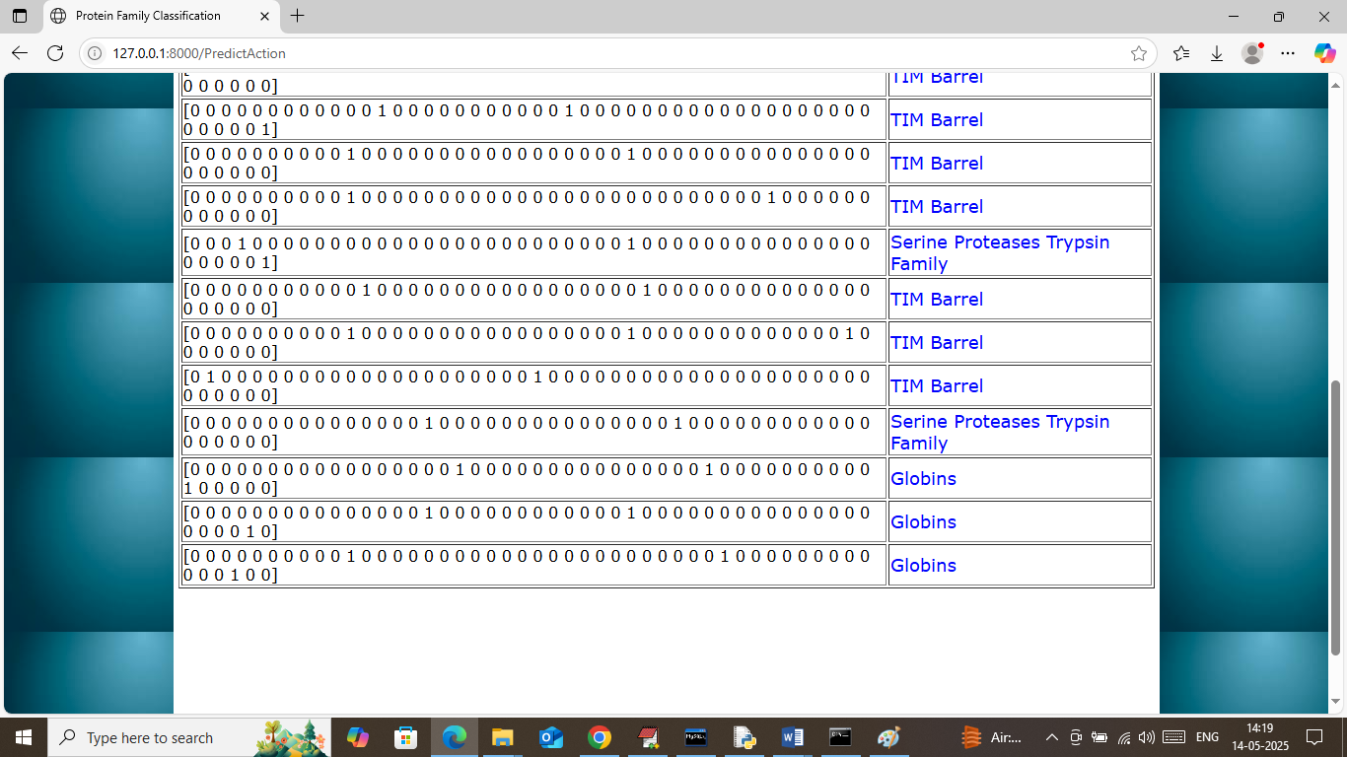
FIG 8.10 TEST DATA VALUES
In above screen can see all predicted family output.

CHAPTER 9: CONCLUSION

9.CONCLUSION
The Protein Family Classification using Deep Learning Techniques project demonstrates how artificial intelligence can be effectively applied in the field of bioinformatics to analyze biological sequence data. The primary goal of this project was to design and implement a system capable of automatically classifying protein sequences into their respective families using deep learning models. By utilizing advanced neural network architectures, the system is able to learn complex patterns present in amino acid sequences and perform accurate classification.
During the development of the project, several important stages were carried out, including data preprocessing, sequence encoding, model development, training, and performance evaluation. Protein sequence data was converted into numerical representations suitable for deep learning models, enabling the system to process and analyze the information efficiently. Deep learning models such as Recurrent Neural Networks (RNN), Long Short-Term Memory (LSTM), and Gated Recurrent Units (GRU) were implemented to capture sequential dependencies within protein sequences.
The results of the system show that deep learning techniques are highly effective in identifying similarities and patterns among protein sequences, which allows accurate classification into protein families. The performance evaluation using metrics such as accuracy, precision, recall, and F1-score confirmed the reliability and effectiveness of the proposed system. Among the implemented models, sequence-based architectures demonstrated strong performance due to their ability to handle sequential biological data.
This project highlights the potential of integrating machine learning and bioinformatics to handle large-scale biological datasets. The developed system provides a scalable and automated approach for protein classification, reducing the need for manual analysis and improving research efficiency. Such systems can support scientists in understanding protein functions, studying evolutionary relationships, and assisting in drug discovery and biomedical research.

CHAPTER 10: FUTURE ENHANCEMENTS

10.FUTURE ENHANCEMENTS

Future enhancements of the proposed protein family classification system can focus on improving model accuracy, scalability, and applicability in real-world bioinformatics research. One potential enhancement is the integration of more advanced deep learning architectures such as Convolutional Neural Networks (CNNs), Transformer-based models, and attention mechanisms, which can capture complex biological sequence patterns more effectively than traditional sequence models. These advanced architectures can improve the ability of the system to recognize subtle similarities and variations among protein sequences.
Another possible improvement is the use of larger and more diverse biological datasets obtained from global protein databases. Training the system with more extensive datasets would allow the model to learn richer biological features and improve its generalization capability for unseen protein sequences. Incorporating transfer learning techniques could also allow the system to leverage pre-trained biological models, reducing training time and improving prediction accuracy.
The system could also be enhanced by integrating protein structural information and functional annotations along with amino acid sequences. Combining multiple types of biological data may provide deeper insights into protein characteristics and significantly improve classification performance. Additionally, incorporating automated feature extraction techniques and embedding-based sequence representations could allow the model to better understand biological sequence relationships without relying heavily on manual preprocessing.
Future versions of the system could also include a real-time prediction interface or web-based application where researchers and bioinformatics professionals can upload protein sequences and receive instant classification results. This would make the system more accessible and practical for research and educational purposes. Furthermore, implementing visualization tools to display sequence patterns, model predictions, and classification confidence levels would help users better interpret the results.
Another potential enhancement is the integration of explainable artificial intelligence (XAI) techniques, such as SHAP or LIME, to provide clear explanations for model predictions. This would help researchers understand how the deep learning model identifies specific features within protein sequences that influence classification decisions.
Finally, the system could be extended to support additional bioinformatics tasks, such as protein function prediction, protein structure analysis, and disease-related protein identification. By expanding the capabilities of the system and incorporating more advanced machine learning techniques, the proposed solution could become a powerful tool for biological research, drug discovery, and computational biology applications.

CHAPTER 11: REFERENCES
11.REFERENCES

- Vazhayil, A., Vinayakumar, R., & Soman, K.P. (2018).
DeepProteomics: Protein family classification using Shallow and Deep Networks. arXiv. arXiv
- Liu, X. L. (2017).
Deep Recurrent Neural Network for Protein Function Prediction from Sequence. bioRxiv. OUCI
- Sandaruwan, D., & Wannige, C. T. (2021).
An improved deep learning model for hierarchical classification of protein families. PLoS ONE. PMC
- Investigation of protein family relationships with deep learning. (2023).
Bioinformatics Advances. OUP Academic+1
- Asgari, E., & Mofrad, M. R. K. (2015).
ProtVec: A Continuous Distributed Representation of Biological Sequences. arXiv. arXiv
- Zulfiqar, R., Khan, T. A., Khan, A. A. et al. (2025).
A review on amino acid-based protein classification using supervised artificial intelligence (AI) models. Discovery Applied Sciences. SpringerLink
- AlQuraishi, M. et al. (2020).
SideChainNet: An All-Atom Protein Structure Dataset. MLSB 2020. mlsb.io+1
- Ali, B., Shah, A., Niaz, M., Mansoord, M., Ullah, S., & Adnan, M. (2024).
A Fusion-Driven Approach of Attention-Based CNN-BiLSTM for Protein Family Classification – ProFamNet. arXiv. arXiv

